
Computer Science Internal Assessment

Caribbean Advanced Proficiency Internal Assessment Project for Computer Science, Unit 2
Candidate Name: Robyn Kejana-Jade Sterling

Table of Contents
Specification of Requirements 3
Background
Problem Context
Problem Definition
Problem Objectives …
Problem Suited SDLC Model
Technique Analysis
Data Flow Diagram: Context Level 7
Data Flow Diagram: Level 1 8
Entity Relationship Diagram 9
Requirements 11
Functional Requirements
Nonfunctional requirements
Design Specifications - System Structure 13
HIPO Chart 14
User Interface 16
Technical Manual 28
Algorithm Design – Pseudocode 59
Data Structures and Record 86
Source Code – C Code 88
Test Plan 110
Test Results 119
Error Trapping 136
Correct Output 139
Usability 141
Conclusion 143
Appendix 144

Problem Definition


Background
Amethyst Accueil is a proficiently active firm, though being relatively small, that distributes a variety of crystals and herbs to the public. In recent times, they’ve started to break through in the market, which has brought them many changes subsequent from opportunities. They established in the late 2021 but began full operation in early 2022. The firm operates within the botanical parish of St. Ann in Jamaica and is family-owned under the Paulichi lineage, to which its location sits at the Mahoe Avenue within that of St. Ann.

Problem Context
In the firm’s digital-based system, they employ a sophisticated payroll management program that accurately calculates compensation for each employee, while accounting for distinct details like their tax levies, overtime contributions and such. Simultaneously, this system generates comprehensive financial reports, providing insights into revenue, expenses, and profits. The firm has also invested in securing these financial documents in the system vault, as well as issuing e-copies to those of whom it may concern, whether internally or externally. Additionally, they maintain an employee filing system within the program, allowing seamless additions, removals, searches, views, and updates. This streamlined approach enhances efficiency, transparency, and effective management of employee records.

Problem Definition
However, the current program exhibits limitations in its functionality, particularly in managing employee records. There is a constraint that restricts the addition of more than six employees to the system, hindering scalability for businesses with larger staff sizes. Additionally, the delete record option appears to be encountering issues, creating potential data management challenges. Furthermore, the linking of pay to employees is nonexistent, posing a significant obstacle in efficiently managing payroll processes. Accessing financial reports and payroll information is also cumbersome, as users are compelled to navigate through the entire system rather than having a streamlined and direct access method.

Problem Objectives
To address the program's limitations, immediate steps should include expanding employee capacity, resolving delete record issues, implementing a direct pay-employee link, and improving system accessibility for streamlined financial reporting and payroll management. Additionally, maintain the update, search, and display functions to match the structure of fixing delete and add records. Create separate files for reports and payrolls to enhance organization and implement date tracking to keep records of time created, ensuring thorough audit trials and efficient management.

SDLC Model
The Agile Model is ideal for Amethyst Accueil due to its flexibility and adaptability. With limited tech knowledge and urgent issues like imbalanced wages and inaccurate records, Agile enables rapid, incremental development. It fosters collaboration, transparency, and iterative refinement based on user feedback, prioritizing critical issues like payroll accuracy early on. Two major advantages of Agile are its flexibility and rapid delivery, accommodating changes even late in development. However, scope creep may prolong schedules and increase budgets. Maintaining an Agile system requires highly skilled individuals, potentially increasing costs. Without skilled personnel, Agile's effectiveness may be compromised.

Technique Analysis
In assessing the efficiency and effectiveness of Amethyst Accueil objectively, various data collection methods were employed to gather feedback on the system's conditions, mainly interviews and questionnaires.
An interview is a real-time conversation between an interviewer and an interviewee. In this case, a structured interview was used, involving predetermined questions to gather in-depth information about the firm's challenges and aspirations. The purpose is to understand stakeholders' expectations and aspirations. Benefits include qualitative insights to address issues hindering program development. The interview covers management's goals for the digital solution, employees' perspectives on challenges during the transition, and IT specialists' technical insights into existing systems and possibilities for integration. With that, only conducting interviews with key people of these departments, to collect the most meaningful data in an efficient manner. Specific issues detailed from the interview were restrictive nature in employee management, the inconsistency in employee data in program’s system in comparison to file’s system and functional features failing to operate successfully/properly.
A questionnaire is a method for collecting information, using a set of questions. In this case, an electronic format with a semi-structured style, combining close-ended and open-ended questions, was employed. The purpose was to collect structured quantitative data on employee satisfaction, concerns, and opinions about the current payroll system. The benefits of using a questionnaire include obtaining quantifiable data for statistical analysis and capturing a broad perspective from the entire workforce. The questionnaire was distributed to all employees to identify their satisfaction, concerns, and opinions, seeking feedback for potential improvements. As well as being mindful of the respondents’ time, the questionnaire was kept succinct and easily interpretable for quick assessment. In response to the questionnaire, it’s been sighted that users are pleased with the system but wish to see a potential improvement in user friendliness, but more importantly functionality as the company begins to grow. Apart from this, ideas were suggested to optimize the current system to meet the new requirements of the firm.

DFD: Context Level
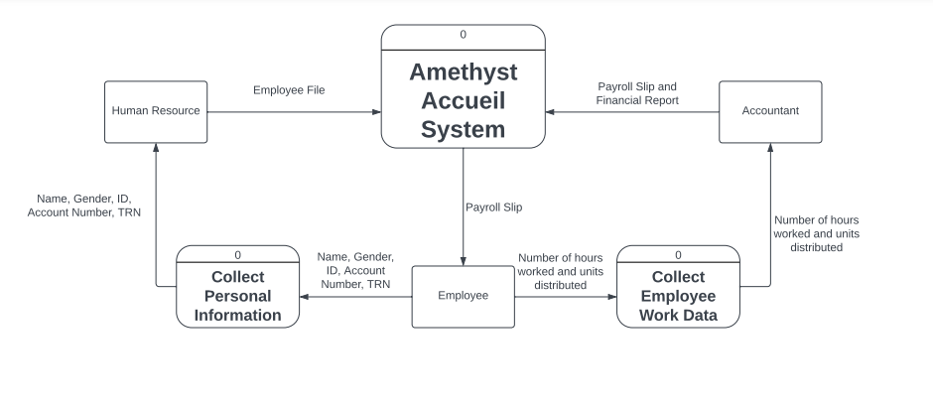

DFD: Level 1
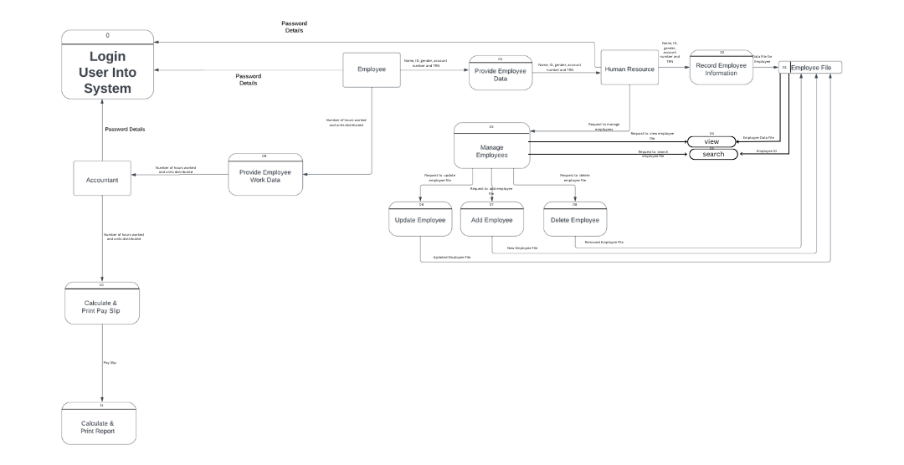

Entity Relationship Diagram
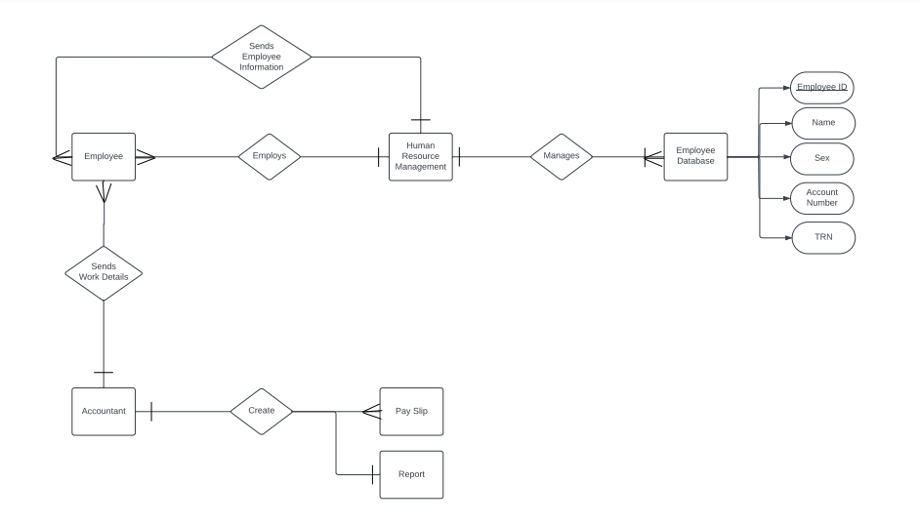
Field Name | Description | Data Size | Data Type | Required
Employee ID | Unique attribute number to identify employee within the firm. |  | Number | Yes
Name | The first and last name of the employee. |  | Text | Yes
Sex | The specific gender (male/female) of the employee. |  | Character | Yes
Account Number | The number that identifies the account number of the employee’s bank details, |  | Number | Yes
TRN | Unique attribute number given upon filing of tax registration number for employee. |  | Number | Yes

Functional Requirements
1. The system will be able to store the net pay value of the employees in a database
2. The system will be able to store the pay slips of every employee in a database
3. The system will be able to store the company's report in a database
4. The system will be able to properly delete employee records
5. The system will be able to add more records to the employee file, by expanding the limit of employees, and display them on the print screen.
6. The system will allow the employee data to be sorted given the users' criteria
7. The system will have an improved search function that allows the employee to be searched by their ID and print all pieces of information associated with that ID/employee.
8. The system will keep track of the date to which employee slips and reports have been filed.

Non-Functional Requirements
1. Login passwords must be inputted using password masking algorithms.
2. The system's code should be written in C Programming Language
3. The system should be available 99.99% of the time, excluding scheduled maintenance of 30
minutes per month.
4. The system should support major web browsers (Chrome, Firefox, Safari) and operating systems (Windows, macOS, Linux)
5. The system's usability should be of ease in terms of user-friendliness, with readable and content attractive layouts to invite and assure a smooth process for the users.
6. The system will be able to handle a great amount of information and values by using a series of functions that will clear the screen, as well as clear the memory after a certain amount of
information is inputted into the system.

Design Specifications
Structured Chart
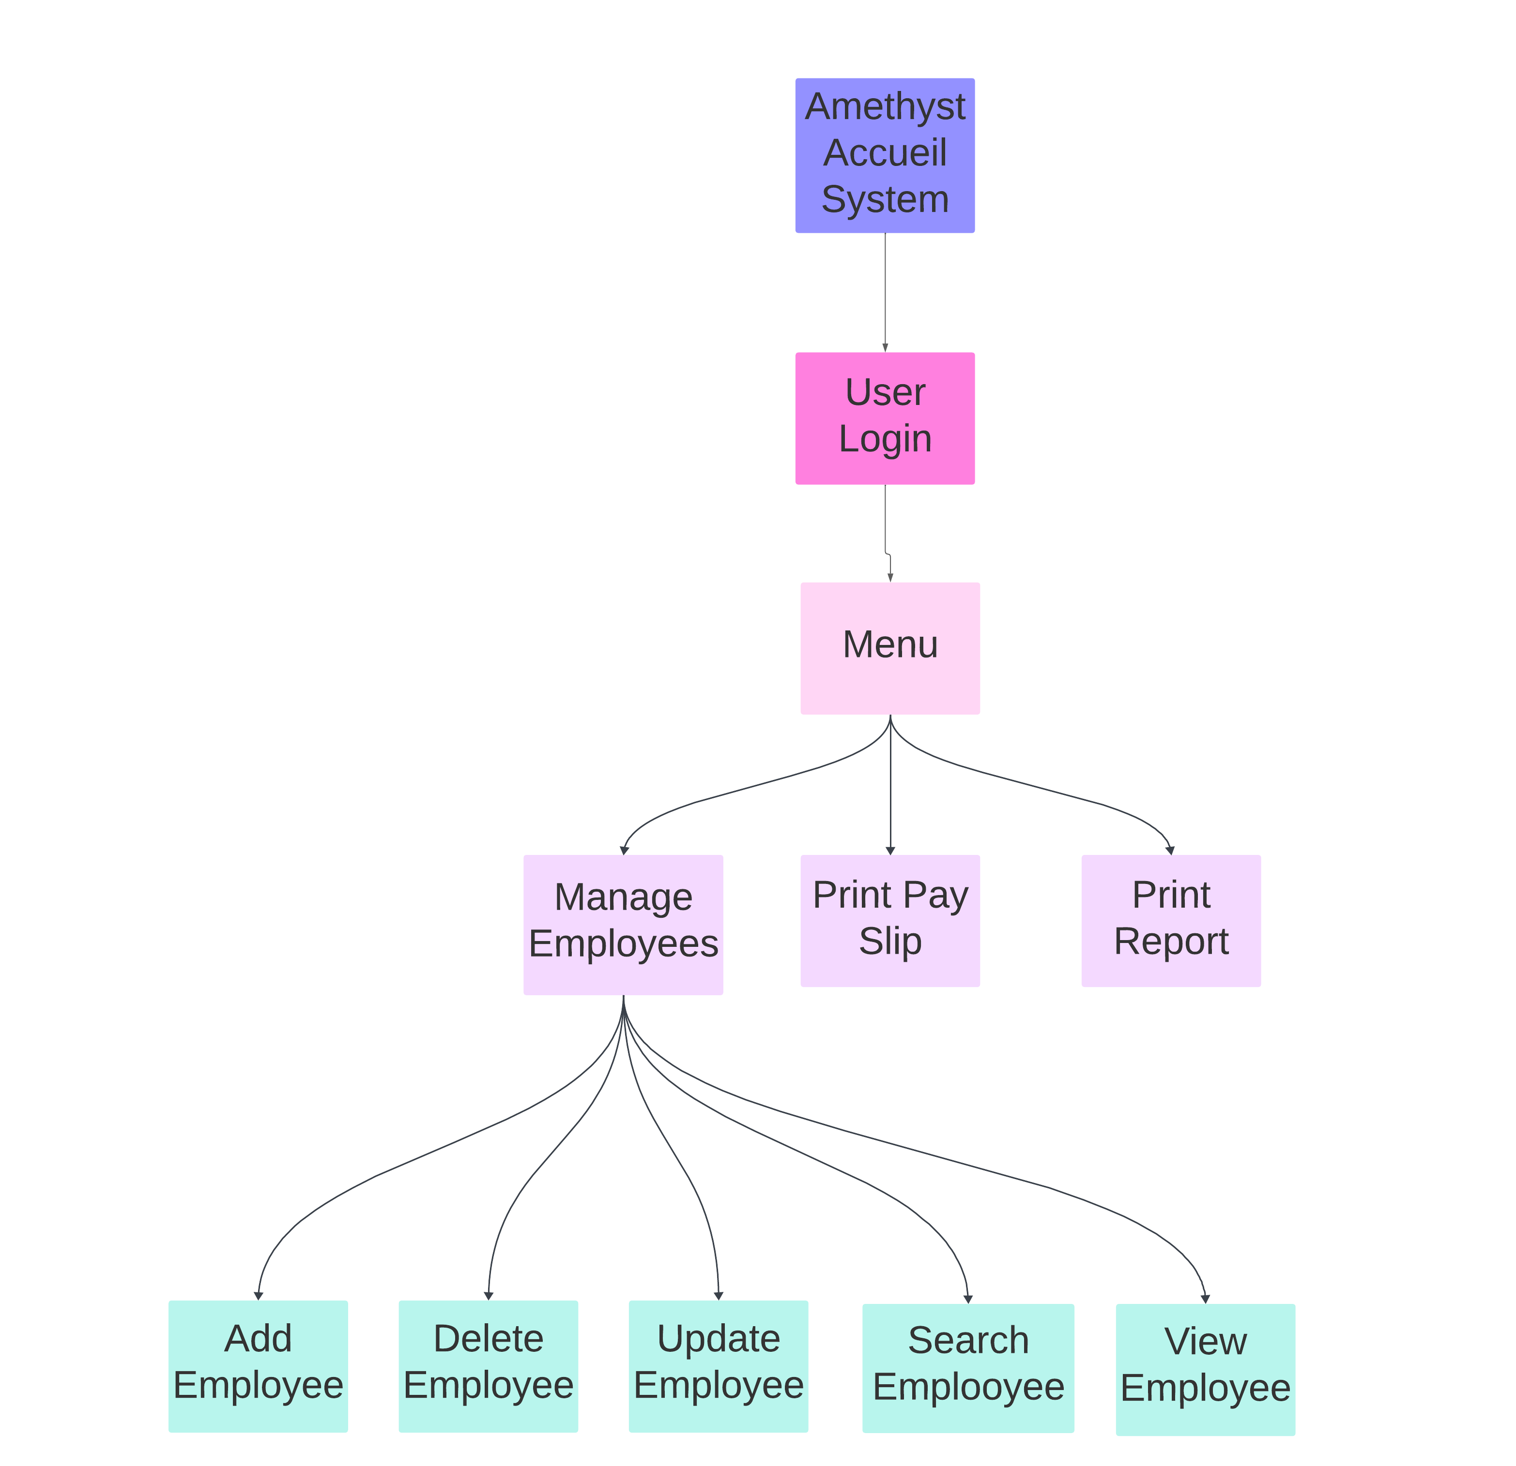

HIPO Chart
1. Main Module
- Input: None
- Process:
- Display welcome message
- Prompt for password
- Call password authentication function
- Output: Access granted or denied

2. Password Authentication Function
- Input: User-entered password
- Process:
- Compare entered password with the correct password
- Allow access if correct, else allow three attempts
- Output: Access granted or denied

3. Employee Management Function
- Input: User-selected option
- Process:
- Display menu options for managing employees
- Execute selected option:
- Display employees
- Update employee records
- Search for an employee
- Delete an employee
- Add a new employee
- Interact with employee.txt file for data manipulation
- Output: Display employee records or perform specified action

4. Pay Slip Generation Function
- Input: Employee data (hours worked, commissions, deductions)
- Process:
- Calculate components of pay slip (basic pay, overtime pay, etc.)
- Display pay slip on screen
- Append pay slip to payslip.txt file
- Output: Display pay slip

5. Report Generation Function
- Input: Total net pays, commissions, deductions
- Process:
- Prompt user to print report
- If selected, display report summary
- Append report to report.txt file
- Output: Display report summary or prompt

6. File Handling
- Input: Data from text files (employee.txt, payslip.txt, report.txt)
- Process:
- Read employee records for display, updating, searching, or deletion
- Write employee data, pay slips, or reports to corresponding files
- Output: Manipulation of text files

7. Other Functions
- Input: None
- Process:
- Clear screen
- Set text color
- Set background color
- Output: Screen display formatting

8. Main Function
- Input: None
- Process:
- Call welcome function
- Call password function
- Call employee management, pay slip generation, and report generation functions
- Output: Program execution

User Interface
The Amethyst Accueil System boasts a command-line-like interface, optimizing response times across its array of functions. This interface eliminates the need for employee users to memorize commands for system navigation. Instead, it offers graphical menus displaying user options, all meticulously crafted with code.

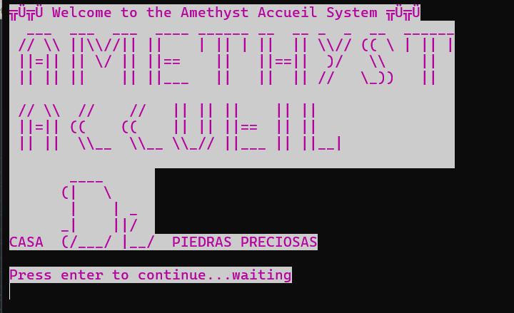
Figure 1. The first screen output to the user is the welcome interface, which displays an inviting greeting to the user, “Welcome to the Amethyst Accueil System”, whilst also prompting the user to login into the system to then be granted access to the system. The name of the system was enlarged in perspective to the other wording to draw emphasis to the firm’s name, whilst also utilizing mostly simplistic font for its readability. The color white was selected to make stark contrast amidst the pink background.

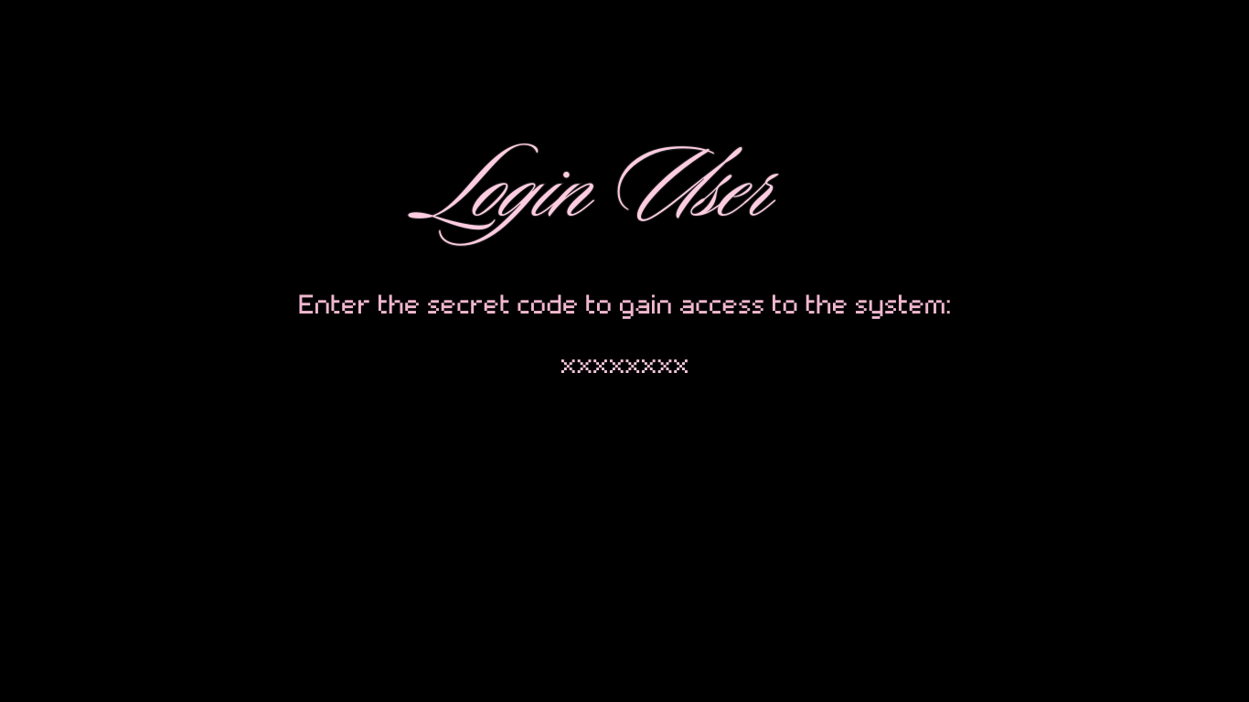
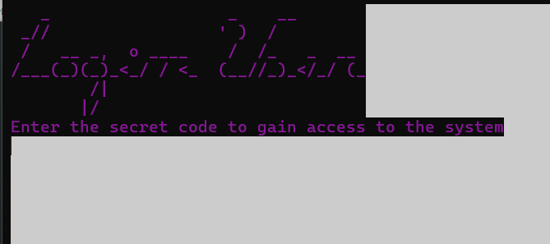
Figure 2. The second screen represents the login screen of the system, this is wherein users are given the ability to input the password to enter the system. After three attempts the user will be logged out of the system and be faced with program termination. In comparison to the welcome screen, the login screen takes on a darker layout to represent the locked state of the system.


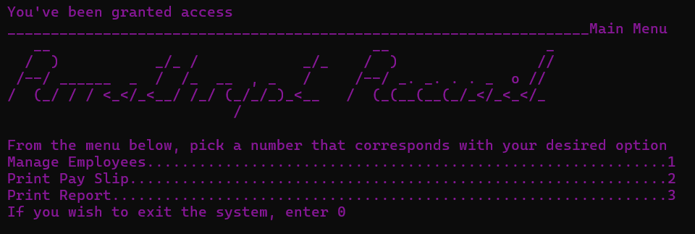
Figure 3. This screen represents the main menu of the system, providing users with the system functions of managing the employees of the database, printing payslip (s) and/or printing report (s). All icons that represent these functions are colorized as light grey, but upon the hover of the mouse over the icon, will turn white to represent the potential selection of users.
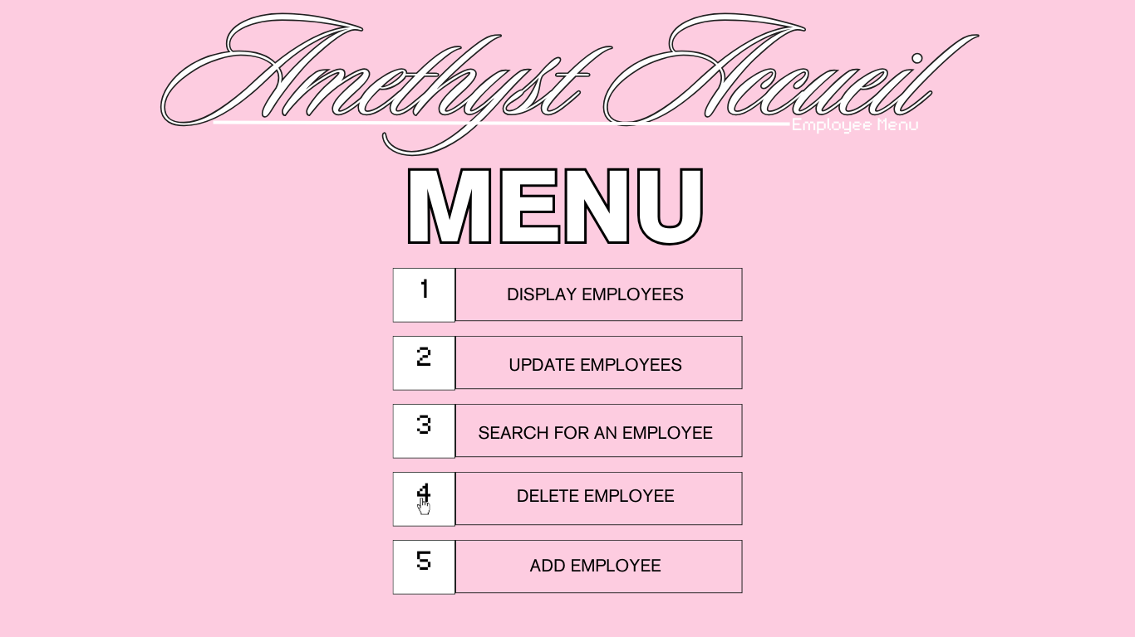
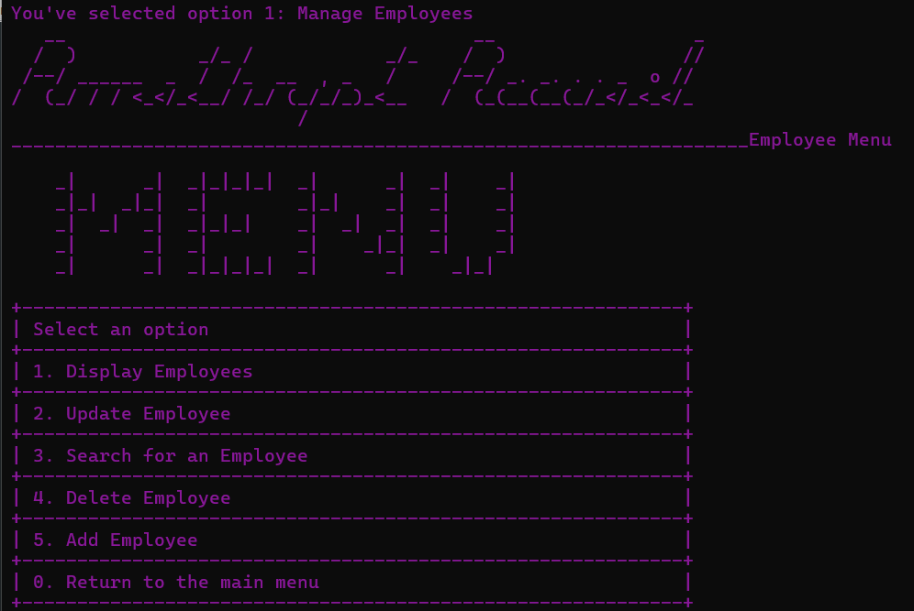
Figure 4. Figure four represents the subsequent menu after selecting the system function of “manage employees”. It prompts the user with a list of options as to how they might want to manage the employee database, from adding, deleting, updating, viewing, or searching for an employee. In the top right corner, lies a link that upon interaction will send the user back to their previous page, in this case the main menu.

Report Design
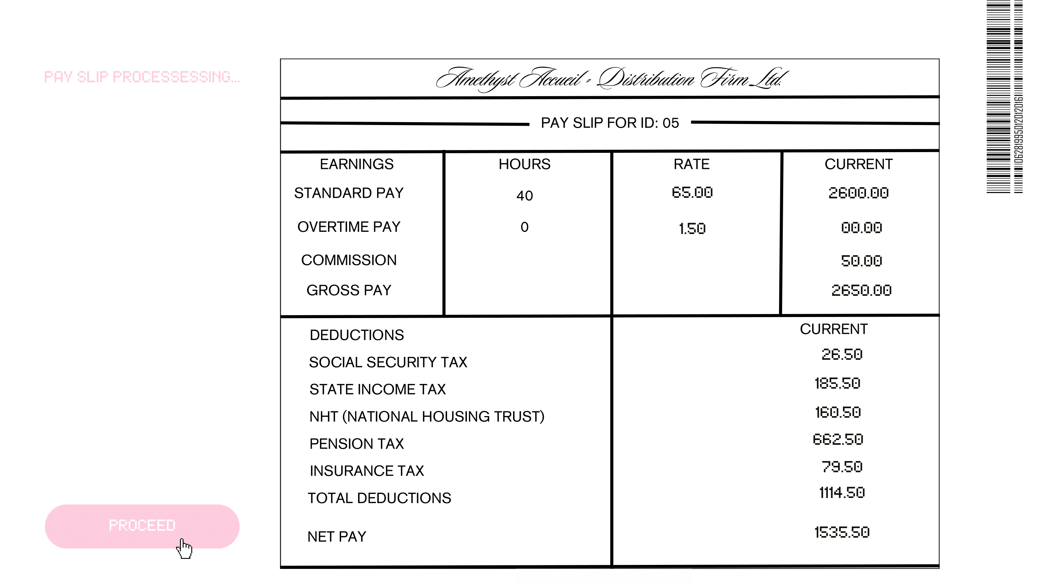
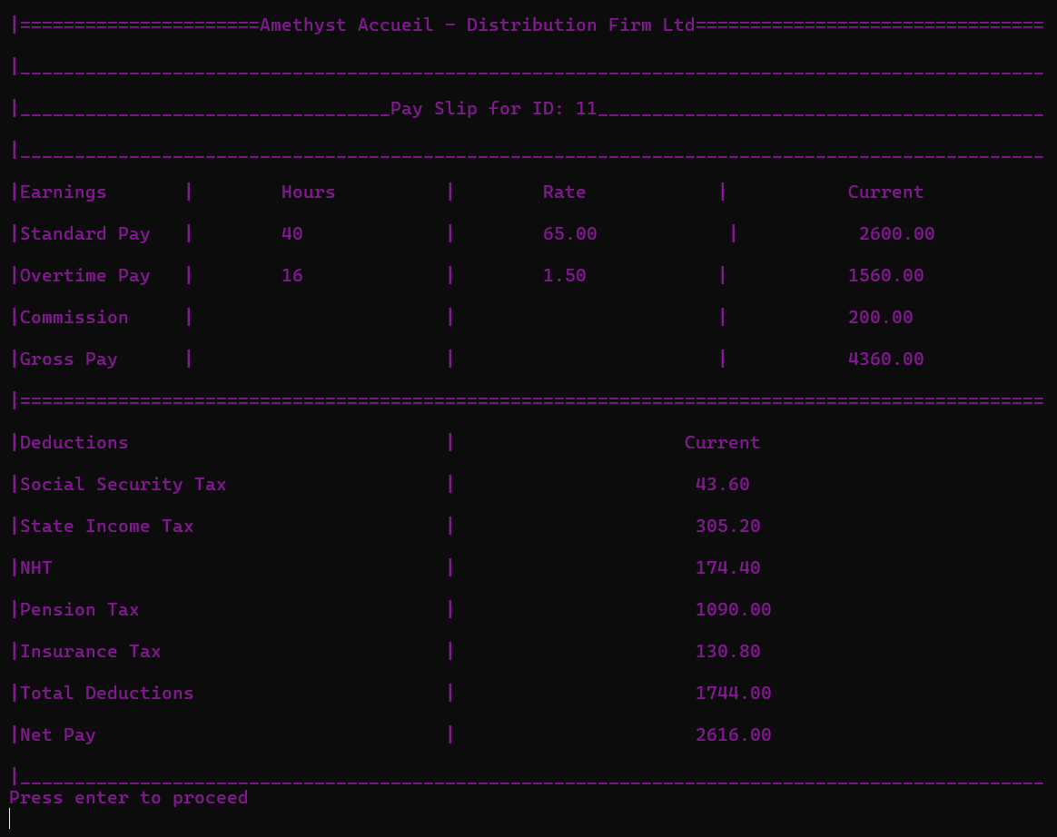
Figure 5. Figure 5 illustrates the report page of the system function, “Print Payslip” after employee work data has been processed. It uses a minimalistic white and black layout for ease of legibility and comparison, alongside the usage of simple word font and size. There is a large pink button the left-hand side, that indicates the option to view the next payslip of an employee.

Report Design
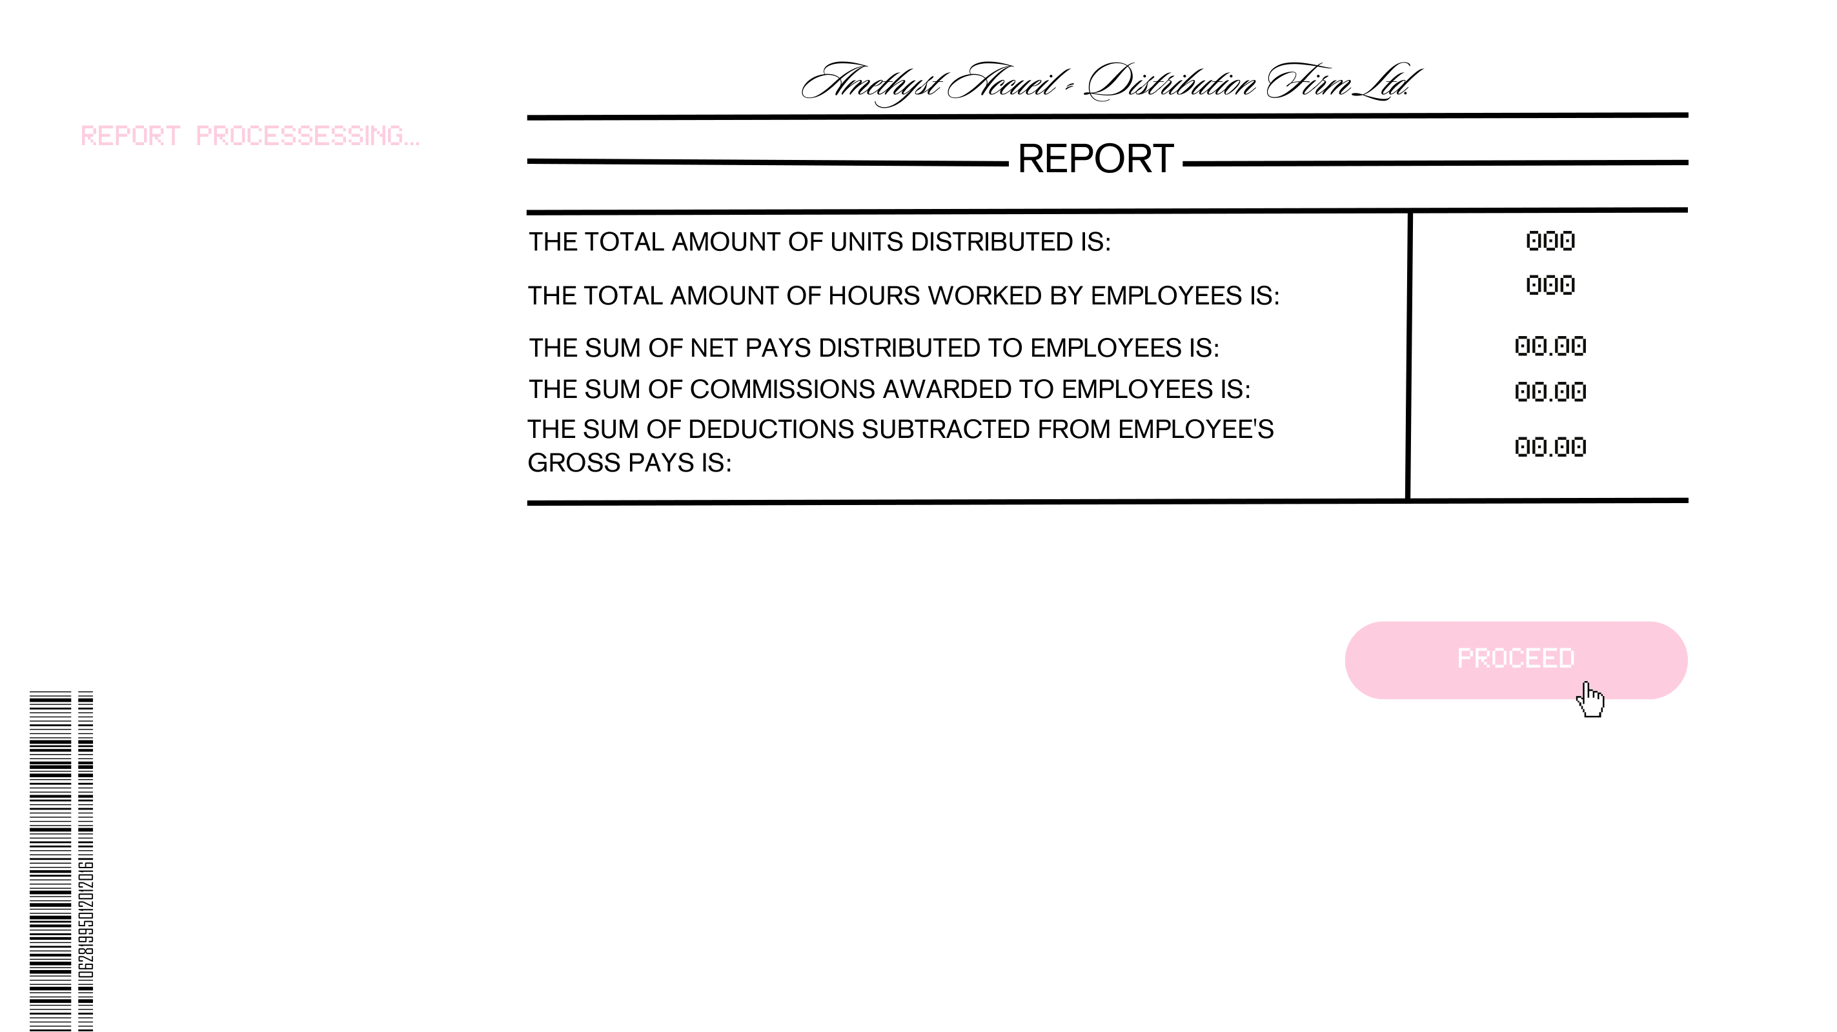
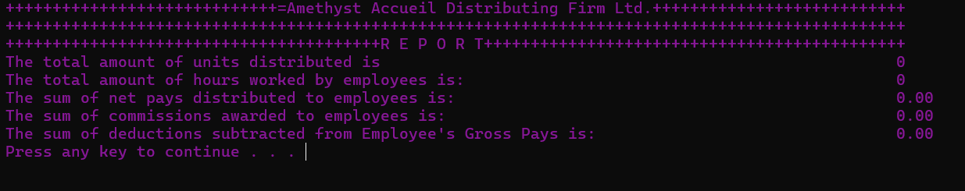
Figure 6. Figure 6, similarly, to figure 5 displays the report page of the system function, “Print Report” after cumulative pay slip data has been processed. It also uses a minimalistic white and black layout for ease of legibility and comparison, alongside the usage of simple word font and size. There is a large pink button the right-hand side, that indicates the option to proceed to the next page of the system, which in this case, would be the main menu.

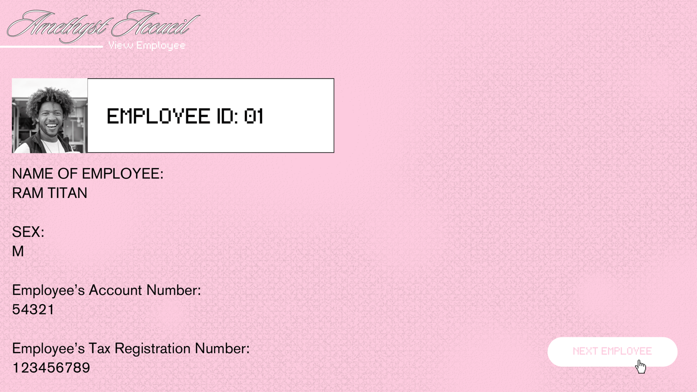
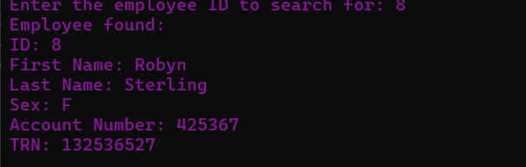
Figure 7. Figure 7 represents the search employee screen, which outputs the headers and information of employees for which the user wished to search. Much like previous screens, the font and size in this screen stays consistent in its readability, as such key information should be easily read without difficulty.


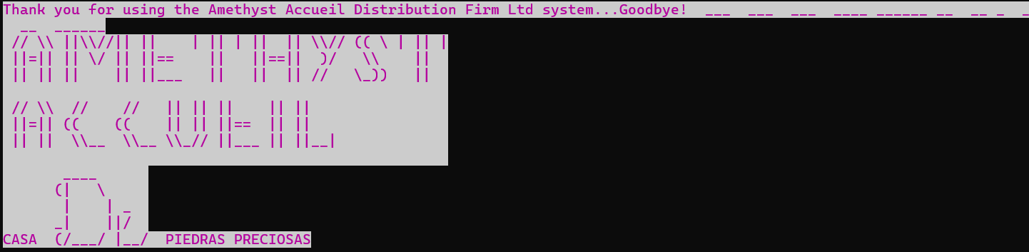
Figure 8. Figure 8 represents the screen presented upon exit of the system, it is the invert of the welcome screen to represent a closed system, using darker colors, but similar word formats to remain consistent.

Technical Manual

Module 1: mor

Narrative
This module will serve to provide the entirety of the code (except for what function “mor_alt_BG” would cover) with graphics. Within this module, contains an ANSI (American National Standards Institutive) color code that will print unto the parts of the code, the code being a regular purple color for the text primarily.

Pseudocode:
void mor ()
Start
print (“\33[0;35m = purple”)
End

Module 2: mor_alt_BG

Narrative
This module will serve to provide the welcome and farewell page of the code with graphics. Within the module, two ANSI (American National Standards Institutive) color codes will be printed unto the parts of the code, the first being a bold high intensity color of purple that will affect the texts, and the second being regular white color that will affect the background of the texts.
Pseudocode
void mor_alt_BG ()
Start
print (“\e[1 = bold; 95m = high purple”)
print (“\e[47m = white”)
Stop

Module 3: welcome

Narrative:
This module will serve to welcome the user to the system, with a generic welcoming message.

Pseudocode:
void welcome ()
START
call to the mor_alt_BG function
print “˚˚ Welcome to the Amethyst Accueil System ˚˚”
Print " ___ ___ ___ ____ ______ __ __ _ _ __ ______"
Print " // \\ \\ ||\\\\//|| || | || | || || \\\\// (( \\ | || |"
Print " ||=|| || \\/ || ||== || ||==|| )/ \\\\ || "
Print " || || || || ||___ || || || // \\_)) || "
Print " "
Print " // \\ // // || || || || || "
Print " ||=|| (( (( || || ||== || || "
Print " || || \\__ \\__ \\\\_// ||___ || ||__| "
Print " "
Print " ____ "
Print " (| \\ "
Print " | | _ "
Print " _| ||/ "
Print "CASA (/\___/ |__/ PIEDRAS PRECIOSAS"

END

Module 4: goodbye

Narrative:
This module will serve to wish the user off the system, with a generic farewell message.

Pseudocode:
void goodbye ()
START
call to the mor_alt_BG function
print “Thank you for using the Amethyst Accueil Distribution Firm Ltd system...Goodbye!"

Print " ___ ___ ___ ____ ______ __ __ _ _ __ ______"
Print " // \\ \\ ||\\\\//|| || | || | || || \\\\// (( \\ | || |"
Print " ||=|| || \\/ || ||== || ||==|| )/ \\\\ || "
Print " || || || || ||___ || || || // \\_)) || "
Print " "
Print " // \\ // // || || || || || "
Print " ||=|| (( (( || || ||== || || "
Print " || || \\__ \\__ \\\\_// ||___ || ||__| "
Print " "
Print " ____ "
Print " (| \\ "
Print " | | _ "
Print " _| ||/ "
Print "CASA (/\___/ |__/ PIEDRAS PRECIOSAS"

END

Module 5: WIPE

Narrative:
This module will serve to clear screen after each usage.

Pseudocode:
void WIPE ()
START
system clear screen
END

Module 6: password (void)

Narrative:
This module will serve to secure the system with a password. It will declare 2 local variables, “ent_pass” and “count” as integers, and initialize two variables, i to 3 and x to 0. After declaring and initializing, the “mor” function will be called to provide color to the module, after which the user will be prompted to enter a secret pin to gain access to the system, this pin will be stored in the variable previously mentioned, being “ent_pass”. The program will read this entered pin and then immediately after clear the screen, by calling to the “WIPE” function. A conditional structure (nested if) will then declare if the user has gained access or not to the system. If the user had initially entered “5791” as the pin, then the system will output the text “You’ve been granted access” and then call to the “menu” function, else the system will call to the “WIPE” function and tell the user that the secret pin they’ve entered is incorrect and to try again, after which the program will use an iteration structure (for loop) to give the user 3 attempts to gain access. The “count” variable will provide the user with the amount of attempts they have remaining after each attempt is made. If any time within those three attempts the pin is correct, then they’ll be taken to the menu; the “menu” function will be called, else the program will output “Access Status = Not granted” and terminate.

Pseudocode:
password ()
START
ent_pass, count, i, x as integer
i = 3
x = 0

Print " _ _ __ "
Print " _// ' ) / "
Print " / __ _, o ____ / /_ _ __ "
Print "/___(_)(_)_<_/ / <_ (__//_)_</_/ (_"
Print " /| "
Print " |/ "

Call to the “mor” function.
print “Enter the secret code to gain access to the system”
read ent_pass

call to WIPE function
if (ent_pass = 5791) then
print “You’ve been granted access”
call to menu function
endif
else
system clear
print “Incorrect Secret Code…Try Again!”
print “You have three attempts”

for x=1 to 3 DO
print “Enter the secret code”
read ent_pass
system clear

x = x + 1
if (ent_pass == 5791) then
print “You’ve been granted access”
calls to the menu function
end if

if (ent_pass <> 5791) then
print “Remaining Attempts:”,3-x
print “Access Status = Not Granted
endif
endfor
endif
END

Module 7: menu

Narrative
This module will serve to present to the user the main menu of the system. It will declare two variables as integers, x and opt, while initializing x to 0. After which, a do…while loop will loop the menu until the user chooses to terminate it with the terminator 0. Within the loop will present the user with four options to choose from; manage employees (represented by the number 1), print the pay slip (represented by the number 2), print the report (represented by the number 3), or exit the system(represented by the number 4). Subsequently, a switch structure will be used to deliver the tasks of each option, if they choose 1, then the “employf” function will be called, if they choose 2, then the “PAYSLIP” function will be called, if they choose 3, then the “report” function will be called and if they choose to exit the system, then the “goodbye” function will be called. If the user happens to enter any value that doesn’t represent any of the options displayed, the system will print “Invalid Choice” and the menu will reappear.

Pseudocode:
menu()
START
x, opt as integer
x = 0
do while (opt > 1 OR opt < 5)

Print "___________________________________________________________________Main Menu"
Print " __ __ _ "
Print " / ) _/_ / _/_ / ) // "
Print "/--/ ______ _ / /_ __ , _ / /--/ _. _. . . _ o // "
Print "/ (_/ / / <_</_<__/ /_/ (_/_/_)_<__ / (_(__(__(_/_</_<_</_ "
Print " / "

print “From the menu below, pick a number that corresponds with your desired option”
print “Manage Employees……………………………………………………………………………………………1”
print “Print Pay Slip……………………………………………………………………………………………………..2”
print “Print Report………………………………………………………………………………………………………3”
print “If you wish to exit the system, enter 0”
read opt
call to WIPE function

case based on opt
case = 1:
print “You’ve selected option 1: Manage Employees”
call to “employ” function

case = 2:
print “You’ve selected option 2: Print Pay Slip”
call to “PAYSLIP” function

case =3:
print “You’ve selected option 3: Print Report”
call to “report” function

case = 0: call to “goodbye” function
exit (0)

default
print “Invalid Choice”

ENDCASE
endwhile
return opt
END

Module 8: getCurrentDate

Narrative
This module functions to retrieve the current date, utilizing the `getCurrentDate` function. It initiates by acquiring the current time and storing it in variable `t`. Subsequently, it employs the `localtime` function to convert the time value into a structure (`tm`) containing information about the local time. Then, utilizing the `strftime` function, it formats this time information into a string with the desired format "YYYY-MM-DD" and stores it in the `date` variable passed as an argument.

Pseudocode:
Declaring void getCurrentDate(char *date)
START
time_t t = time (NULL)
struct tm * tm = localtime (&t);
strftime (date, 20, “&Y-%m-%d”, tm);
STOP

Module 9: PAYSLIP

Narrative
This module aims to generate and print pay slips for each employee within the system. It begins by declaring various variables, including integers like `i`, `hrs_wrk`, `ov_hrs`, and `units_dis`, along with real numbers such as `bas_pay`, `g_p`, `ot`, `com`, `net_p`, `ss_tax`, `st_inc_tax`, `NHT`, `pen`, `insur`, and `t_deduc`. Additionally, a string variable named `cho` is declared.

The constants `bas_hrly_r`, `over_r`, and `bas_hrs` are initialized, representing hourly rates, overtime rates, and standard hours respectively.

The process iterates through each employee, prompting for hours worked and units distributed. Based on these inputs, it calculates overtime pay, basic pay, commission, gross pay, and various deductions including taxes, pension, and insurance. The net pay is then determined.

The user is given the option to print the pay slip for each employee. If chosen, the program generates a formatted pay slip and saves it to a file named "payslip.txt". If not, it proceeds to the next employee. If an invalid response is entered, it informs the user and continues. After processing all employees, it returns to the main menu function.

The program utilizes the `WIPE` function to clear the screen and pauses for user acknowledgment before proceeding to the menu.

Pseudocode:
Declaring void PAYSLIP (float *total_np, float *total_com, float *total_td)
START

char date [20]
call to getCurrentDate (date)

hrs_work, i, ov_hrs, units_dis as integer
bas_pay, g_p, ot, com, net_p as real
ss_tax, st_inc_tax, NHT, pen, insur, t_deduc as real
cho as string
bas_hrly_r, over_r as float
bas_hrs as integer
const bas_hrly_r = 65.00
const over_r = 1.5
const bas_hrs = 40

print “For which employee would you like to print the payslip?”
read empid

file named “employee.txt” open in read-only mode
if (file == NULL) then
print “An error occurred while opening this file.”
return;
endif

while reading from file until all data is processed{
IF (EMP [t_emp].id = empid) Then

print “Processing for Employee ID”, emp_id[i]
print “Enter the number of hours worked by the employee”
read hrs_wrk

total_hw = total_hw + hrs_wrk

if (hrs_wrk > bas_hrs) then
ov_hrs = hrs_wrk – bas_hrs
ot = 00.00
bas_pay = bas_hrly_r * bas_hrs
endif
else if (hrs_wrk < bas_hrs) then
ov_hrs = 0
ot = 00.00
bas_pay = bas_hrly_r * bas_hrs
endif

print “Enter the number of units distributed by the employee”
read units_dis
total_ud = total_ud + units_dis

if (units_dis >= 200 AND units_dis < 250) then
com = 50.00
total_com = total_com + com
endif
else if (units_dis >= 250 AND units_dis < 300) then
com = 100.00
total_com = total_com + com
endif
else if (units_dis >= 300 AND units_dis<400) then
com = 150.00
total_com = total_com + com
endif
elseif (units_dis >= 400) then
com = 200.00
total_com = total_com + com
endif
else
com = 00.00
total_com = total_com + com
endif

g_p = com + ot + bas_pay

ss_tax = g_p * 0.01
st_inc_tax = g_p * 0.07
NHT = g_p * 0.04
pen = g_p * 0.25
insur = g_p * 0.03
t_deduc = ss_tax + st_inc_tax + NHT + pen + insur
total_td = total_td + t_deduc

net_p = g_p – t_deduc
total_np = total_np + net_P
system clear screen

print “Would you like to print the employee’s pay slip , Yes or No?”
read cho

Call to the WIPE function
if (cho = “Yes”)then

Print "Amethyst Accueil - Distribution Firm Ltd"
Print "-----------------------------------------------------------------------------------------------------\n"
Print "Pay Slip"
Print "---------------------------------------------------------------------------------------------------\n"
Print "Earnings | Hours | Rate | Current"
Print "Standard Pay:”, | bas_hrs | bas_hrly_r | bas_pay
Print "Overtime Pay:”, | ov _hrs | over_r | ot
Print "Commission value:”, | | | com
Print "Gross Pay:”, | | | g_p
Print "------------------------------------------------------------------------------------------------------"
Print "Deductions | Current"
Print "Social Security Tax | “,ss_tax
Print "State Income Tax | ",st_inc_tax
Print "NHT | ",NHT
Print "Pension Tax | ",pen
Print "Insurance Tax | ",insur
Print "Total Deductions | ",t_deduc
Print "Net Pay ",net_p

file3 named “payslip.txt” open in append mode
if (file3 == NULL) then
print "An error has occurred while opening this file"
return 1
endif

writefile(file3, "|====================================================================================Date: %s", date)
writefile(file3, "|======================Amethyst Accueil - Distribution Firm Ltd================================")
writefile(file3, "|______________________________________________________________________________________________")
writefile(file3, "|__________________________________Pay Slip for ID: %d_________________________________________")
writefile(file3, "|______________________________________________________________________________________________")
writefile(file3, "|Earnings | Hours | Rate | Current ")
writefile(file3, "|Standard Pay | %d | %.2f | %.2f ", bas_hrs, bas_hrly_r, bas_pay)
writefile(file3, "|Standard Pay | %d | %.2f | %.2f ", hrs_wrk, bas_hrly_r, bas_pay)
writefile(file3, "|Overtime Pay | %d | %.2f | %.2f ", ov_hrs, over_r, ot)
writefile(file3, "|Commission | | | %.2f ", com)
writefile(file3, "|Gross Pay | | | %.2f ")
writefile(file3, "|==============================================================================================")
writefile(file3, "|Deductions | Current ")
writefile(file3, "|Social Security Tax | %.2f ", ss_tax)
writefile(file3, "|State Income Tax | %.2f ", st_inc_tax)
writefile(file3, "|NHT | %.2f ", NHT)
writefile(file3, "|Pension Tax | %.2f ", pen)
writefile(file3, "|Insurance Tax | %.2f ", insur)
writefile(file3, "|Total Deductions | %.2f ", t_deduc)
writefile(file3, "|Net Pay | %.2f ", net_p)
writefile(file3, "|______________________________________________________________________________________________")

fclose(file3)

print "Press enter to proceed"
char c = getchar()
ELSE IF strcmp(cho, "No") == 0 THEN
PRINT "To proceed, press enter...\n"
ELSE
PRINT "Invalid Response...Proceeding...Press enter\n"
END IF

getch()
END IF
END WHILE

system("pause")
WIPE ()
PRINT "\nPress the enter key to go back to the menu\n"
CHAR c = getchar()
END FUNCTION

Module 10: report

Narrative:
Narrative:
This module is designed to generate and print a report summarizing various key metrics related to employee performance and financials. It begins by invoking the `getCurrentDate` function to retrieve the current date.

The `WIPE` function is called to clear the screen for better readability. The user is prompted to decide whether they want to print the report. If the response is "Yes," the program proceeds to generate a formatted report containing the total units distributed, total hours worked by employees, total net pays distributed, total commissions awarded, and total deductions subtracted from employees' gross pays.

The program then pauses for user acknowledgment before proceeding to write the report to a file named "report.txt." If any errors occur during file handling, an error message is displayed.

After writing the report to the file, the program pauses again for user acknowledgment before calling the `WIPE` function to clear the screen once more.

If the user chooses not to print the report, the program simply proceeds to the end without generating the report or writing it to a file.

Pseudocode:
Declaring void report (float total_np, float total_com, float total_td)
START
ans as string
ans as date
Call to the getCurrent Date (date) function

call to the “WIPE” function
print “Would you like to print the Report, Yes or No? “
read ans

if (ans = “Yes”) then
print "++++++Amethyst Accueil Distributing Firm Ltd.++++++++++++++++"
print"++++++++++++++++++++++++++++++++++++++++++++++++++++++++"
printf ("+++++++++++++++++++++++R E P O R T++++++++++++++++++++++"
print "The total amount of units distributed is ", total_ud
print ("The total amount of hours worked by employees is: ", total_hw
printf ("The sum of net pays distributed to employees is: ", total_np
printf ("The sum of commissions awarded to employees is: ", total_com
printf ("The sum of deductions subtracted from Employee's Gross Pays is: ", total_td
system pause

// Creating and writing to file4
file4 named "report.txt" open in write mode
if (file4 == NULL) then
print "An error has occurred while opening file4"
return
endif

writefile(file4, "Date: %s\n", date)
writefile(file4, "Total Units Distributed: %d\n", total_ud)
writefile(file4, "Total Hours Worked: %d\n", total_hw)
writefile(file4, "Total Net Pays Distributed: %.2f\n", total_np)
writefile(file4, "Total Commissions Awarded: %.2f\n", total_com)
writefile(file4, "Total Deductions: %.2f\n", total_td)
fclose(file4)

system("pause")
endif

WIPE() // calls to the wipe function
}

ENDIF

END

Module 11: employf

Narrative
This module facilitates the management of employee records within a system. It begins by initializing various variables and pointers needed for the operation. The user is presented with a menu offering several options, including displaying employees, updating employee information, searching for an employee, deleting an employee, adding a new employee, or returning to the main menu.

Upon selecting an option, the program executes the corresponding functionality:

1. Display Employee: The system opens the "employee.txt" file and reads and displays each line, presenting the employee records to the user.

2. Update Employee: The system prompts the user to enter the ID of the employee they wish to update. It then searches for the employee in the file, allows the user to update the employee's details, and writes the updated information back to the file.

3. Search for an Employee: The user is prompted to enter the ID of the employee they want to search for. The system reads through the file, searching for the specified ID, and if found, displays the employee's details.

4. Delete Employee: The user is prompted to enter the ID of the employee they want to delete. The system reads through the file, deletes the specified employee's record, and updates the file accordingly.

5. Add Employee: The system prompts the user to enter details for a new employee, including ID, first name, last name, sex, account number, and TRN. It then appends this information to the "employee.txt" file.

The module operates in a loop until the user chooses to return to the main menu by entering 0. If the user selects an invalid option, the system prompts them with an "Invalid Choice" message. Overall, this module provides essential functionality for managing employee records efficiently.

Pseudocode:
Declaring employf (int *id, char*fname, char *lname, char *sex, int *acc, int *trn)
START

FUNCTION flushInputBuffer()
// Flush the input buffer
READ character FROM stdin UNTIL character = '\n' OR character = EOF
END FUNCTION

DECLARE
employees AS employ POINTER
numEmployees, arraySize, i, sel, search_num AS INTEGER
foundb, found AS BOOLEAN
c, ano AS CHARACTER
line[MAX_LINE_SIZE] AS STRING

arraySize = t_emp
foundb = false

Repeat until sel equals 0:
Print " __ __ _ "
Print " / ) _/_ / _/_ / ) // "
Print " /--/ ______ _ / /_ __ , _ / /--/ _. _. . . _ o // "
Print "/ (_/ / / <_</_<__/ /_/ (_/_/_)_<__ / (_(__(__(_/_</_<_</_ "
Print " / "
Print "___________________________________________________________________Employee Menu"

Print "\n _| _| _|_|_|_| _| _| _| _|"
Print " _|_| _|_| _| _|_| _| _| _|"
Print " _| _| _| _|_|_| _| _| _| _| _|"
Print " _| _| _| _| _|_| _| _|"
Print " _| _| _|_|_|_| _| _| _|_| "

Print "\n+------------------------------------------------------------+"
Print "| Select an option |"
Print "+------------------------------------------------------------+"
Print "| 1. Display Employees |"
Print "+------------------------------------------------------------+"
Print "| 2. Update Employee |"
Print "+------------------------------------------------------------+"
Print "| 3. Search for an Employee |"
Print "+------------------------------------------------------------+"
Print "| 4. Delete Employee |"
Print "+------------------------------------------------------------+"
Print "| 5. Add Employee |"
Print "+------------------------------------------------------------+"
Print "| 0. Return to the main menu |"
Print "+------------------------------------------------------------+"
read sel // Scan the user's selection

WIPE() // Call the WIPE function to clear the input buffer

case 1:
print("Selected Option: 1...Display Employees");

Open file named "employee.txt" in read mode

IF file == NULL THEN
PRINT "An error has occurred while opening the file"
RETURN
END IF
print("Employee records:");

// Read and display each line in the file
Repeat until end of file {
Read a line from file
Print the line
}

Close file
break;

case 2:
print("Selected Option: 2...Update Employee");

Open file named "employee.txt" in read mode
IF file == NULL THEN
PRINT "Error opening file."
RETURN
END IF

Open file named "copy.employee.txt" in write mode
IF file2 == NULL THEN
PRINT "Error opening file."
CLOSE file
RETURN
END IF

print("Enter the ID of the Employee to update:");
read search_num;

// Loop through each record in the original file
Repeat until end of file {
Read record from file
IF EMP[t_emp].id == search_num THEN
PRINT "Employee found:"
PRINT "ID: ", EMP[t_emp].id
PRINT "First Name: ", EMP[t_emp].fname
PRINT "Last Name: ", EMP[t_emp].lname
PRINT "Sex: ", EMP[t_emp].sex
PRINT "Account Number: ", EMP[t_emp].acc
PRINT "TRN: ", EMP[t_emp].trn

PRINT "Enter new first name of Employee:"
READ EMP[t_emp].fname FROM stdin
PRINT "Enter new last name for Employee:"
READ EMP[t_emp].lname FROM stdin
PRINT "Enter new sex of Employee:"
READ EMP[t_emp].sex FROM stdin
PRINT "Enter new Employee's Account Number:"
READ EMP[t_emp].acc FROM stdin
PRINT "Enter New Employee's Tax Registration Number:"
READ EMP[t_emp].trn FROM stdin

found = true
END IF

WRITE line TO file2
END WHILE

CLOSE file
CLOSE file2

IF found THEN
REMOVE("employee.txt")
RENAME("copy.employee.txt", "employee.txt")
PRINT "Record updated successfully."
ELSE
PRINT "Record doesn't seem to exist."
REMOVE("copy.employee.txt")
END IF

BREAK

case 3:
print("Selected Option: 3...Search for an Employee");

Open file named "employee.txt" in read mode

PRINT "Enter the employee ID to search for: "
READ search_num FROM stdin
CLEAR INPUT BUFFER

IF file == NULL THEN
PRINT "An error has occurred while opening the file"
RETURN
END IF

// Read and search each line in the file
Repeat until end of file {
Read record from file
if (EMP[t_emp].id == search_num) {
// If employee found, print details
print("Employee found:");
PRINT "ID: ", EMP[t_emp].id
PRINT "First Name: ", EMP[t_emp].fname
PRINT "Last Name: ", EMP[t_emp].lname
PRINT "Sex: ", EMP[t_emp].sex
PRINT "Account Number: ", EMP[t_emp].acc
PRINT "TRN: ", EMP[t_emp].trn
foundb = true;
BREAK
END IF
END WHILE

IF NOT foundb THEN
PRINT "Employee with ID ", search_num, " not found"
END IF

CLOSE file
BREAK

case 4:
PRINT "Selected Option 4...Delete Employee"

Open file named "employee.txt" in read mode
IF file == NULL THEN
PRINT "An error has occurred while opening the file"
RETURN
END IF

Open file named "copy.employee.txt" in write mode

IF file2 == NULL THEN
PRINT "An error has occurred while opening the file"
RETURN
END IF

print("Enter the ID of the Employee to delete:");
read search_num;

// Loop through each record in the original file
Repeat until end of file {
Read record from file
if (EMP[t_emp].id == search_num) {
// If the ID matches the search ID, skip writing this record to the temporary file
print("Employee found and deleted:")
PRINT "ID: ", EMP[t_emp].id
PRINT "First Name: ", EMP[t_emp].fname
PRINT "Last Name: ", EMP[t_emp].lname
PRINT "Sex: ", EMP[t_emp].sex
PRINT "Account Number: ", EMP[t_emp].acc
PRINT "TRN: ", EMP[t_emp].trn
foundb = true; // Set found flag to true
else
Write record to file2
End If
End While
Close file; // Close the original file
Close file2; // Close the temporary file

if (foundb) {
// Replace the original file with the temporary file
If foundb Then
Delete "employee.txt"
Rename "copy.employee.txt" to "employee.txt"
Print "Record deleted successfully."
Else
Print "Record doesn't seem to exist."
Delete "copy.employee.txt"
End If
BREAK

case 5:
print("Selected Option: Add Employee")

// Open file for appending
file named "employee.txt" open in append mode

if (file is NULL):
print("An error has occurred while opening this file")
return 1
endif

For i from 0 to t_emp
Print "Enter the employee's ID:"
Read EMP[i].id
Clear input buffer

Print "Enter the employee's first name:"
Read EMP[i].fname
Clear input buffer

Print "Enter the employee's last name:"
Read EMP[i].lname
Clear input buffer

Print "Enter the employee's sex:"
Read EMP[i].sex
Clear input buffer

Print "Enter the employee's account number:"
Read EMP[i].acc
Clear input buffer

Print "Enter the employee's TRN:"
Read EMP[i].trn
Clear input buffer

Write to file: "%d,%s,%s,%c,%d,%d\n",
EMP[i].id,
EMP[i].fname,
EMP[i].lname,
EMP[i].sex,
EMP[i].acc,
EMP[i].trn

Print "Employee record successfully stored"

// Ask if the user wants to add another employee
IF i < t_emp - 1 THEN
Declare choice as char
Print "Do you want to add another employee? (y/n):"
Read choice
If choice is not 'y' and choice is not 'Y' Then
BREAK
Exit loop
End If
End If
End For

Close file
BREAK

case = 0: call to “menu” function
BREAK

DEFAULT: print “Invalid Choice”
BREAK

END SWITCH

END REPEAT
END

Module 12: main

Narrative
This module serves as the driver of the program.

The program begins by executing a series of functions to initialize the system and welcome the user. First, the `welcome()` function is called to greet the user and introduce them to the system. After displaying the welcome message, the program prompts the user to press enter to continue.

Once the user confirms, the `WIPE()` function is called to clear the screen, ensuring a clean interface for the next step. Subsequently, the `mor()` function is executed, presenting additional information or instructions to the user, possibly related to the system's purpose or functionality.

Following that, the `password()` function is invoked to prompt the user to enter a password or authentication information to access the system's main features or functionalities. This step enhances security and ensures authorized access.

After entering the password, the program again calls the `WIPE()` function to clear the screen, maintaining a neat display. At this point, the system is ready for further interaction with the user, who can then proceed to access the main menu or perform other tasks as needed.

Overall, this sequence of function calls sets up the initial environment of the system, greets the user, provides necessary instructions, handles authentication, and prepares the interface for user interaction.

Pseudocode:
// Function prototype Declarations
void welcome();
void mor();
void password();
void WIPE();
void menu();
void employf();
void report(float total_np, float total_com, float total_td);
void mor_alt_BG();
void goodbye();
void PAYSLIP(float *total_np, float *total_com, float *total_td);

START
int main():

// Call to the welcome function
welcome()

// Prompt to continue
print("Press enter to continue...waiting")
char c = getchar()

// Call to the WIPE function
WIPE()

// Call to the mor function
mor()

// Call to the password function
password()

// Call to the WIPE function
WIPE()

STOP

Algorithm Design

Programmer: Robyn Sterling of 602-B

Course: Computer Science

Format: Database and Accounting Styling

Description:
- Manage a set of employees and records
- Features include searching, display, adding, removing, and updating
- Ability to compute individual pay slips and company reports with minimal data input
- Data recorded in separate files for organization

Start Date: November 24, 2022
End Date: April 7, 2024

// Libraries
Include "stdlib"
Include "stdio"
Include "conio"
Include "string"
Include "stdbool"
Include "time"

// Constants
const t_emp = 6
const MAX_LINE_SIZE = 100

// Record Definition
RECORD employ
DECLARE
id, acc, trn AS Integer
fname, lname AS String
sex AS Character
END DECLARE
END RECORD

// Global Variables
DECLARE
total_ud, total_hw AS Integer
total_np, total_com, total_td AS Real
file, file2, file3, file4 AS File
EMP[t_emp] AS employ
END DECLARE

// Algorithm/Function to set text color to magenta
FUNCTION mor ()
PRINT "\033[0;35m" // Set text color to magenta
END FUNCTION

// Algorithm/Function to set text color to magenta and background color to light magenta
FUNCTION mor_alt_BG ()
PRINT "\e[1;95m" // Set text color to magenta
PRINT "\e[47m" // Set background color to light magenta
END FUNCTION

// Algorithm to display a welcome message to the user
FUNCTION welcome ()
mor_alt_BG () // Calls to the background graphic function
PRINT "˚˚ Welcome to the Amethyst Accueil System ˚˚\n"

Print " ___ ___ ___ ____ ______ __ __ _ _ __ ______"
Print " // \\ \\ ||\\\\//|| || | || | || || \\\\// (( \\ | || |"
Print " ||=|| || \\/ || ||== || ||==|| )/ \\\\ || "
Print " || || || || ||___ || || || // \\_)) || "
Print " "
Print " // \\ // // || || || || || "
Print " ||=|| (( (( || || ||== || || "
Print " || || \\__ \\__ \\\\_// ||___ || ||__| "
Print " "
Print " ____ "
Print " (| \\ "
Print " | | _ "
Print " _| ||/ "
Print "CASA (/\___/ |__/ PIEDRAS PRECIOSAS"

END FUNCTION

// Algorithm to display a goodbye message to the user
FUNCTION goodbye ()
mor_alt_BG () // Calls to the background graphic function
PRINT "Thank you for using the Amethyst Accueil Distribution Firm Ltd system...Goodbye!"
Print " ___ ___ ___ ____ ______ __ __ _ _ __ ______"
Print " // \\ \\ ||\\\\//|| || | || | || || \\\\// (( \\ | || |"
Print " ||=|| || \\/ || ||== || ||==|| )/ \\\\ || "
Print " || || || || ||___ || || || // \\_)) || "
Print " "
Print " // \\ // // || || || || || "
Print " ||=|| (( (( || || ||== || || "
Print " || || \\__ \\__ \\\\_// ||___ || ||__| "
Print " "
Print " ____ "
Print " (| \\ "
Print " | | _ "
Print " _| ||/ "
Print "CASA (/\___/ |__/ PIEDRAS PRECIOSAS"

END FUNCTION

// Algorithm/Function to clear the screen
FUNCTION WIPE ()
system ("cls") // Clears the screen
END FUNCTION

// Algorithm/Function to clear the input buffer
FUNCTION clearInputBuffer()
DECLARE c AS Integer
WHILE ((c = getchar()) != '\n' AND c != EOF)
// Keep reading characters until encountering a newline or end-of-file
END WHILE
END FUNCTION

Declare void password (void)
START
ent_pass, count, i, x as integer
i = 3
x = 0

Print " _ _ __ "
Print " _// ' ) / "
Print " / __ _, o ____ / /_ _ __ "
Print "/___(_)(_)_<_/ / <_ (__//_)_</_/ (_"
Print " /| "
Print " |/ "

Call to the “mor” function.
print “Enter the secret code to gain access to the system”
read ent_pass

call to the wipe function
if (ent_pass = 5791) then
print “You’ve been granted access”
call to menu function
endif
else
system clear
print “Incorrect Secret Code…Try Again!”
print “You have three attempts”

for x=1 to 3 DO
print “Enter the secret code”
read ent_pass
system clear

x = x + 1
if (ent_pass == 5791) then
print “You’ve been granted access”
calls to the menu function
end if

if (ent_pass <> 5791) then
print “Remaining Attempts:”,3-x
print “Access Status = Not Granted
endif
endfor
endif
STOP

Declaring void menu (void)
START
x, opt as integer
x = 0
do while (opt > 1 OR opt < 5)

Print "___________________________________________________________________Main Menu"
Print " __ __ _ "
Print " / ) _/_ / _/_ / ) // "
Print "/--/ ______ _ / /_ __ , _ / /--/ _. _. . . _ o // "
Print "/ (_/ / / <_</_<__/ /_/ (_/_/_)_<__ / (_(__(__(_/_</_<_</_ "
Print " / "

print “From the menu below, pick a number that corresponds with your desired option”
print “Manage Employees……………………………………………………………………………………………1”
print “Print Pay Slip……………………………………………………………………………………………………..2”
print “Print Report………………………………………………………………………………………………………3”
print “If you wish to exit the system, enter 0”
read opt
system clear screen

case based on opt
case = 1:
print “You’ve selected option 1: Manage Employees”
call to “employ” function

case = 2:
print “You’ve selected option 2: Print Pay Slip”
call to “PAYSLIP” function

case =3:
print “You’ve selected option 3: Print Report”
call to “report” function

case = 0: call to “goodbye” function
exit (0)

default
print “Invalid Choice”

ENDCASE
endwhile
return opt

STOP

Declaring void getCurrentDate(char *date)
START
time_t t = time (NULL)
struct tm * tm = localtime (&t);
strftime (date, 20, “&Y-%m-%d”, tm);

Declaring void PAYSLIP (float *total_np, float *total_com, float *total_td)
START

char date [20]
call to getCurrentDate (date)

hrs_work, i, ov_hrs, units_dis as integer
bas_pay, g_p, ot, com, net_p as real
ss_tax, st_inc_tax, NHT, pen, insur, t_deduc as real
cho as string
bas_hrly_r, over_r as float
bas_hrs as integer
const bas_hrly_r = 65.00
const over_r = 1.5
const bas_hrs = 40

print “For which employee would you like to print the payslip?”
read empid

file named “employee.txt” open in read-only mode
if (file == NULL) then
print “An error occurred while opening this file.”
return;
endif

while reading from file until all data is processed{
IF (EMP [t_emp].id = empid) Then

print “Processing for Employee ID”, emp_id[i]
print “Enter the number of hours worked by the employee”
read hrs_wrk

total_hw = total_hw + hrs_wrk

if (hrs_wrk > bas_hrs) then
ov_hrs = hrs_wrk – bas_hrs
ot = 00.00
bas_pay = bas_hrly_r * bas_hrs
endif
else if (hrs_wrk < bas_hrs) then
ov_hrs = 0
ot = 00.00
bas_pay = bas_hrly_r * bas_hrs
endif

print “Enter the number of units distributed by the employee”
read units_dis
total_ud = total_ud + units_dis

if (units_dis >= 200 AND units_dis < 250) then
com = 50.00
total_com = total_com + com
endif
else if (units_dis >= 250 AND units_dis < 300) then
com = 100.00
total_com = total_com + com
endif
else if (units_dis >= 300 AND units_dis<400) then
com = 150.00
total_com = total_com + com
endif
elseif (units_dis >= 400) then
com = 200.00
total_com = total_com + com
endif
else
com = 00.00
total_com = total_com + com
endif

g_p = com + ot + bas_pay

ss_tax = g_p * 0.01
st_inc_tax = g_p * 0.07
NHT = g_p * 0.04
pen = g_p * 0.25
insur = g_p * 0.03
t_deduc = ss_tax + st_inc_tax + NHT + pen + insur
total_td = total_td + t_deduc

net_p = g_p – t_deduc
total_np = total_np + net_P
system clear screen

print “Would you like to print the employee’s pay slip , Yes or No?”
read cho

Call to the WIPE function
if (cho = “Yes”)then

Print "Amethyst Accueil - Distribution Firm Ltd"
Print "-----------------------------------------------------------------------------------------------------\n"
Print "Pay Slip"
Print "---------------------------------------------------------------------------------------------------\n"
Print "Earnings | Hours | Rate | Current"
Print "Standard Pay:”, | bas_hrs | bas_hrly_r | bas_pay
Print "Overtime Pay:”, | ov _hrs | over_r | ot
Print "Commission value:”, | | | com
Print "Gross Pay:”, | | | g_p
Print "------------------------------------------------------------------------------------------------------"
Print "Deductions | Current"
Print "Social Security Tax | “,ss_tax
Print "State Income Tax | ",st_inc_tax
Print "NHT | ",NHT
Print "Pension Tax | ",pen
Print "Insurance Tax | ",insur
Print "Total Deductions | ",t_deduc
Print "Net Pay ",net_p

file3 named “payslip.txt” open in append mode
if (file3 == NULL) then
print "An error has occurred while opening this file"
return 1
endif

writefile(file3, "|====================================================================================Date: %s", date)
writefile(file3, "|======================Amethyst Accueil - Distribution Firm Ltd================================")
writefile(file3, "|______________________________________________________________________________________________")
writefile(file3, "|__________________________________Pay Slip for ID: %d_________________________________________")
writefile(file3, "|______________________________________________________________________________________________")
writefile(file3, "|Earnings | Hours | Rate | Current ")
writefile(file3, "|Standard Pay | %d | %.2f | %.2f ", bas_hrs, bas_hrly_r, bas_pay)
writefile(file3, "|Standard Pay | %d | %.2f | %.2f ", hrs_wrk, bas_hrly_r, bas_pay)
writefile(file3, "|Overtime Pay | %d | %.2f | %.2f ", ov_hrs, over_r, ot)
writefile(file3, "|Commission | | | %.2f ", com)
writefile(file3, "|Gross Pay | | | %.2f ")
writefile(file3, "|==============================================================================================")
writefile(file3, "|Deductions | Current ")
writefile(file3, "|Social Security Tax | %.2f ", ss_tax)
writefile(file3, "|State Income Tax | %.2f ", st_inc_tax)
writefile(file3, "|NHT | %.2f ", NHT)
writefile(file3, "|Pension Tax | %.2f ", pen)
writefile(file3, "|Insurance Tax | %.2f ", insur)
writefile(file3, "|Total Deductions | %.2f ", t_deduc)
writefile(file3, "|Net Pay | %.2f ", net_p)
writefile(file3, "|______________________________________________________________________________________________")

fclose(file3)

print "Press enter to proceed"
char c = getchar()
ELSE IF strcmp(cho, "No") == 0 THEN
PRINT "To proceed, press enter...\n"
ELSE
PRINT "Invalid Response...Proceeding...Press enter\n"
END IF

getch()
END IF
END WHILE

system("pause")
WIPE ()
PRINT "\nPress the enter key to go back to the menu\n"
CHAR c = getchar()
END FUNCTION

Declaring void report (float total_np, float total_com, float total_td)
START
ans as string
ans as date
Call to the getCurrent Date (date) function

call to the “WIPE” function
print “Would you like to print the Report, Yes or No? “
read ans

if (ans = “Yes”) then
print "++++++Amethyst Accueil Distributing Firm Ltd.++++++++++++++++"
print"++++++++++++++++++++++++++++++++++++++++++++++++++++++++"
printf ("+++++++++++++++++++++++R E P O R T++++++++++++++++++++++"
print "The total amount of units distributed is ", total_ud
print ("The total amount of hours worked by employees is: ", total_hw
printf ("The sum of net pays distributed to employees is: ", total_np
printf ("The sum of commissions awarded to employees is: ", total_com
printf ("The sum of deductions subtracted from Employee's Gross Pays is: ", total_td
system pause

// Creating and writing to file4
file4 named "report.txt" open in write mode
if (file4 == NULL) then
print "An error has occurred while opening file4"
return
endif

writefile(file4, "Date: %s\n", date)
writefile(file4, "Total Units Distributed: %d\n", total_ud)
writefile(file4, "Total Hours Worked: %d\n", total_hw)
writefile(file4, "Total Net Pays Distributed: %.2f\n", total_np)
writefile(file4, "Total Commissions Awarded: %.2f\n", total_com)
writefile(file4, "Total Deductions: %.2f\n", total_td)
fclose(file4)

system("pause")
endif

WIPE() // calls to the wipe function
}

ENDIF

END

Declaring employf (int *id, char*fname, char *lname, char *sex, int *acc, int *trn)
START

FUNCTION flushInputBuffer()
// Flush the input buffer
READ character FROM stdin UNTIL character = '\n' OR character = EOF
END FUNCTION

DECLARE
employees AS employ POINTER
numEmployees, arraySize, i, sel, search_num AS INTEGER
foundb, found AS BOOLEAN
c, ano AS CHARACTER
line[MAX_LINE_SIZE] AS STRING

arraySize = t_emp
foundb = false

Repeat until sel equals 0:
Print " __ __ _ "
Print " / ) _/_ / _/_ / ) // "
Print " /--/ ______ _ / /_ __ , _ / /--/ _. _. . . _ o // "
Print "/ (_/ / / <_</_<__/ /_/ (_/_/_)_<__ / (_(__(__(_/_</_<_</_ "
Print " / "
Print "___________________________________________________________________Employee Menu"

Print "\n _| _| _|_|_|_| _| _| _| _|"
Print " _|_| _|_| _| _|_| _| _| _|"
Print " _| _| _| _|_|_| _| _| _| _| _|"
Print " _| _| _| _| _|_| _| _|"
Print " _| _| _|_|_|_| _| _| _|_| "

Print "\n+------------------------------------------------------------+"
Print "| Select an option |"
Print "+------------------------------------------------------------+"
Print "| 1. Display Employees |"
Print "+------------------------------------------------------------+"
Print "| 2. Update Employee |"
Print "+------------------------------------------------------------+"
Print "| 3. Search for an Employee |"
Print "+------------------------------------------------------------+"
Print "| 4. Delete Employee |"
Print "+------------------------------------------------------------+"
Print "| 5. Add Employee |"
Print "+------------------------------------------------------------+"
Print "| 0. Return to the main menu |"
Print "+------------------------------------------------------------+"
read sel // Scan the user's selection

WIPE() // Call the WIPE function to clear the input buffer

case 1:
print("Selected Option: 1...Display Employees");

Open file named "employee.txt" in read mode

IF file == NULL THEN
PRINT "An error has occurred while opening the file"
RETURN
END IF
print("Employee records:");

// Read and display each line in the file
Repeat until end of file {
Read a line from file
Print the line
}

Close file
break;

case 2:
print("Selected Option: 2...Update Employee");

Open file named "employee.txt" in read mode
IF file == NULL THEN
PRINT "Error opening file."
RETURN
END IF

Open file named "copy.employee.txt" in write mode
IF file2 == NULL THEN
PRINT "Error opening file."
CLOSE file
RETURN
END IF

print("Enter the ID of the Employee to update:");
read search_num;

// Loop through each record in the original file
Repeat until end of file {
Read record from file
IF EMP[t_emp].id == search_num THEN
PRINT "Employee found:"
PRINT "ID: ", EMP[t_emp].id
PRINT "First Name: ", EMP[t_emp].fname
PRINT "Last Name: ", EMP[t_emp].lname
PRINT "Sex: ", EMP[t_emp].sex
PRINT "Account Number: ", EMP[t_emp].acc
PRINT "TRN: ", EMP[t_emp].trn

PRINT "Enter new first name of Employee:"
READ EMP[t_emp].fname FROM stdin
PRINT "Enter new last name for Employee:"
READ EMP[t_emp].lname FROM stdin
PRINT "Enter new sex of Employee:"
READ EMP[t_emp].sex FROM stdin
PRINT "Enter new Employee's Account Number:"
READ EMP[t_emp].acc FROM stdin
PRINT "Enter New Employee's Tax Registration Number:"
READ EMP[t_emp].trn FROM stdin

found = true
END IF

WRITE line TO file2
END WHILE

CLOSE file
CLOSE file2

IF found THEN
REMOVE("employee.txt")
RENAME("copy.employee.txt", "employee.txt")
PRINT "Record updated successfully."
ELSE
PRINT "Record doesn't seem to exist."
REMOVE("copy.employee.txt")
END IF

BREAK

case 3:
print("Selected Option: 3...Search for an Employee");

Open file named "employee.txt" in read mode

PRINT "Enter the employee ID to search for: "
READ search_num FROM stdin
CLEAR INPUT BUFFER

IF file == NULL THEN
PRINT "An error has occurred while opening the file"
RETURN
END IF

// Read and search each line in the file
Repeat until end of file {
Read record from file
if (EMP[t_emp].id == search_num) {
// If employee found, print details
print("Employee found:");
PRINT "ID: ", EMP[t_emp].id
PRINT "First Name: ", EMP[t_emp].fname
PRINT "Last Name: ", EMP[t_emp].lname
PRINT "Sex: ", EMP[t_emp].sex
PRINT "Account Number: ", EMP[t_emp].acc
PRINT "TRN: ", EMP[t_emp].trn
foundb = true;
BREAK
END IF
END WHILE

IF NOT foundb THEN
PRINT "Employee with ID ", search_num, " not found"
END IF

CLOSE file
BREAK

case 4:
PRINT "Selected Option 4...Delete Employee"

Open file named "employee.txt" in read mode
IF file == NULL THEN
PRINT "An error has occurred while opening the file"
RETURN
END IF

Open file named "copy.employee.txt" in write mode

IF file2 == NULL THEN
PRINT "An error has occurred while opening the file"
RETURN
END IF

print("Enter the ID of the Employee to delete:");
read search_num;

// Loop through each record in the original file
Repeat until end of file {
Read record from file
if (EMP[t_emp].id == search_num) {
// If the ID matches the search ID, skip writing this record to the temporary file
print("Employee found and deleted:")
PRINT "ID: ", EMP[t_emp].id
PRINT "First Name: ", EMP[t_emp].fname
PRINT "Last Name: ", EMP[t_emp].lname
PRINT "Sex: ", EMP[t_emp].sex
PRINT "Account Number: ", EMP[t_emp].acc
PRINT "TRN: ", EMP[t_emp].trn
foundb = true; // Set found flag to true
else
Write record to file2
End If
End While
Close file; // Close the original file
Close file2; // Close the temporary file

if (foundb) {
// Replace the original file with the temporary file
If foundb Then
Delete "employee.txt"
Rename "copy.employee.txt" to "employee.txt"
Print "Record deleted successfully."
Else
Print "Record doesn't seem to exist."
Delete "copy.employee.txt"
End If
BREAK

case 5:
print("Selected Option: Add Employee")

// Open file for appending
file named "employee.txt" open in append mode

if (file is NULL):
print("An error has occurred while opening this file")
return 1
endif

For i from 0 to t_emp
Print "Enter the employee's ID:"
Read EMP[i].id
Clear input buffer

Print "Enter the employee's first name:"
Read EMP[i].fname
Clear input buffer

Print "Enter the employee's last name:"
Read EMP[i].lname
Clear input buffer

Print "Enter the employee's sex:"
Read EMP[i].sex
Clear input buffer

Print "Enter the employee's account number:"
Read EMP[i].acc
Clear input buffer

Print "Enter the employee's TRN:"
Read EMP[i].trn
Clear input buffer

Write to file: "%d,%s,%s,%c,%d,%d\n",
EMP[i].id,
EMP[i].fname,
EMP[i].lname,
EMP[i].sex,
EMP[i].acc,
EMP[i].trn

Print "Employee record successfully stored"

// Ask if the user wants to add another employee
IF i < t_emp - 1 THEN
Declare choice as char
Print "Do you want to add another employee? (y/n):"
Read choice
If choice is not 'y' and choice is not 'Y' Then
BREAK
Exit loop
End If
End If
End For

Close file
BREAK

case = 0: call to “menu” function
BREAK

DEFAULT: print “Invalid Choice”
BREAK

END SWITCH

END REPEAT
END

// Function prototype Declarations
void welcome();
void mor();
void password();
void WIPE();
void menu();
void employf();
void report(float total_np, float total_com, float total_td);
void mor_alt_BG();
void goodbye();
void PAYSLIP(float *total_np, float *total_com, float *total_td);

START
int main():

// Call to the welcome function
welcome()

// Prompt to continue
print("Press enter to continue...waiting")
char c = getchar()

// Call to the WIPE function
WIPE()

// Call to the mor function
mor()

// Call to the password function
password()

// Call to the WIPE function
WIPE()

STOP

Data Structures and Records
Employ is a record data type structure (typedef) that stores various personal information of the employees of the firm. This data structure is accompanied by an array called EMP, that is, there is the implementation of a structure of an array, entitled “employ EMP [t_emp]”, with an array (t_emp) of size 6. This structure of an array was implemented mainly in the employf function, due to it being a function that maintains employee management, but also made appearances in the payslip function, so as for ease of cross referencing.

Structuring employee data within an array streamlines organization, with each element representing an employee and attributes delineating specific information like ID and name. As employee numbers increase, array usage simplifies management processes, enabling easy addition or removal of employees. Array-based iteration facilitates streamlined operations across all employees or specific subsets, enhancing efficiency and scalability in data manipulation tasks.

Attribute | Data Type | Purpose
Id | integer | An integer field utilized to assign a unique identification number to each employee, facilitating efficient data retrieval and management.
Fname | String | A character array of size 50, intended to store the first name of the employee for personal identification and reference.
Lname | string | A character array of size 50, designated for storing the last name of the employee for personal identification and reference.
Sex | Character | A character variable employed to denote the gender or sex of the employee.
Acc | Integer | To store information related to the employee's account, potentially used for financial or administrative purposes.
Trn | Integer | To store information related to the employee's government issued tax registration number.

Source Code - C Code
1 /*
2 Programmer: Robyn Sterling of 602-B
3
4 Course: CS
5
6 Format: This program is a combination of a database and an accounting styling format.
7
8 Description: It will allow the user to manage a set of employees and records, given the ability to do
9 things from searching, display, adding, removing and updating...the user will also have the ability to compute
10 an individual's customized pay slip as well as a company's report, by inputting a minimal amount of data. These
11 pieces of data will all be recorded in separate files, for ease of data allocation.
12
13 Program Start Date: November 24, 2022
14
15 Program End Date: April 7, 2024
16 */
17
18 //Libraries
19 #include <stdlib.h>
20 #include <stdio.h>
21 #include <conio.h>
22 #include <string.h>
23 #include <stdbool.h>
24 #include <time.h>
25
26 //Constants
27 #define t_emp 6//defining size of primary array
28 #define MAX_LINE_SIZE 100 // Maximum size of a line in the file
29
30 //declaration and initialization of variables
31 typedef struct
32 {
33 int id;
34 char fname[50];
35 char lname[50];
36 char sex;
37 int acc;
38 int trn;
39 } employ;
40
41 //Global Variables
42 int total_ud, total_hw;//due to the simplicity of these variables, data leakages are not at risk
43 float total_np, total_com, total_td;//due to the simplicity of these variables, data leakages are not at risk
44 FILE *file, *file2, *file3, *file4;//declaring three files
45 //declaring elements of the structure, "employ" to be set in the array, "EMP" with an array size of, "t_emp".
46 employ EMP [t_emp];
47
48
49 //Algorithm/Function for color graphic
50 void mor () {
51 printf("\033[0;35m");
52 }
53
54 //Algorithm/Function for color graphic.2 and BG color graphic
55 void mor_alt_BG (){
56 printf ("\e[1;95m");
57 printf ("\e[47m");
58 }
59
60 //Algorithm that welcomes the user to the system
61 void welcome (){
62 mor_alt_BG ();//calls to the background graphic function
63 printf ("ËšËš Welcome to the Amethyst Accueil System ËšËš\n");
64 printf(" ___ ___ ___ ____ ______ __ __ _ _ __ ______\n");
65 printf(" // \\\\ ||\\\\//|| || | || | || || \\\\// (( \\ | || |\n");
66 printf(" ||=|| || \\/ || ||== || ||==|| )/ \\\\ || \n");
67 printf(" || || || || ||___ || || || // \\_)) || \n");
68 printf(" \n");
69 printf(" // \\\\ // // || || || || || \n");
70 printf(" ||=|| (( (( || || ||== || || \n");
71 printf(" || || \\\\__ \\\\__ \\\\_// ||___ || ||__| \n");
72 printf(" \n");
73
74 printf(" ____ \n");
75 printf(" (| \\ \n");
76 printf(" | | _ \n");
77 printf(" _| ||/ \n");
78 printf("CASA (/\___/ |__/ PIEDRAS PRECIOSAS\n");
79
80
81
82 }
83
84 //Algorithm that wishes the user off the system
85 void goodbye (){
86 mor_alt_BG ();//calls to the background graphic function
87 printf ("Thank you for using the Amethyst Accueil Distribution Firm Ltd system...Goodbye!");
88
89 printf(" ___ ___ ___ ____ ______ __ __ _ _ __ ______\n");
90 printf(" // \\\\ ||\\\\//|| || | || | || || \\\\// (( \\ | || |\n");
91 printf(" ||=|| || \\/ || ||== || ||==|| )/ \\\\ || \n");
92 printf(" || || || || ||___ || || || // \\_)) || \n");
93 printf(" \n");
94 printf(" // \\\\ // // || || || || || \n");
95 printf(" ||=|| (( (( || || ||== || || \n");
96 printf(" || || \\\\__ \\\\__ \\\\_// ||___ || ||__| \n");
97 printf(" \n");
98
99 printf(" ____ \n");
100 printf(" (| \\ \n");
101 printf(" | | _ \n");
102 printf(" _| ||/ \n");
103 printf("CASA (/\___/ |__/ PIEDRAS PRECIOSAS\n");
104 }
105 //Algorithm/Function that clears screem
106 void WIPE (){
107 system ("cls");//implements a clear screen
108 }
109
110 void clearInputBuffer() {
111 int c;
112 while ((c = getchar()) != '\n' && c != EOF);
113 }
114
115 //Algorithm/Function for Passcode implementation
116 void password (void)
117 {//begins the password function
118
119 //declaration and initialization of variables
120 int ent_pass, count;
121 int i=3;
122 int x = 0;
123
124
125 printf(" _ _ __ \n");
126 printf(" _// ' ) / \n");
127 printf(" / __ _, o ____ / /_ _ __ \n");
128 printf("/___(_)(_)_<_/ / <_ (__//_)_</_/ (_\n");
129 printf(" /| \n");
130 printf(" |/ \n");
131
132 mor();//implements text color as purple
133 printf ("Enter the secret code to gain access to the system\n");//prompts the user to enter a secret code
134 scanf ("%d", &ent_pass);//reads the secret code entered
135 WIPE ();//calls to the WIPE function
136
137 if (ent_pass == 5791)
138 {//begins the if statement
139 printf ("You've been granted access\a\n");//outputs a success message
140 menu();//calls to the menu function
141 }//ends the if statement
142
143 else
144 {//begins the else of the if statement
145 WIPE ();//calls to the WIPE function
146 printf ("Incorrect Secret Code...Try Again!\n");//outputs a failure message
147 printf ("You have three attempts\n");//outputs the amount of attempts the user has to gain access to the system
148
149 for (x = 1;x <= 3 && ent_pass != 5791; x++)//gives the user three attempts to enter the system through loop
150 {//begins the for loop
151
152 printf ("\nRe-enter the secret code\n");//prompts the user to re-enter the secret code
153 scanf ("%d", &ent_pass);//reads the entered secret code
154 WIPE ();//calls to the WIPE function
155
156 if(ent_pass == 5791)//if this condition is determined to be true, the user gains entry into the system
157 {//begins the if statement
158 printf ("You've been granted access\a\n");//prompts success message
159 menu();//calls to the menu function after entering the correct code
160 }//ends the if statement
161
162 if(ent_pass != 5791)//if this condition is determined to be true, the user is denied of entry into the system
163 {//begins the if statement
164 printf ("Remaining Attempts: %d \n",3-x);//calculates the amount of attempts the user has left after each loop
165 printf ("Access Status = Not Granted\n");//displays the user with their periodic access status
166 }//ends the if statement
167
168 }//ends the for loop
169
170 }//ends the else of the if statement
171
172 }//ends the password function
173
174 //Algorithm/Function that prompts menu
175 void menu()
176 {//begins the menu function
177
178 //declaration and initialization of variables
179 int x = 0, opt;
180
181 do
182 {//begins do...while loop
183
184
185 printf ("___________________________________________________________________Main Menu\n");
186 printf(" __ __ _ \n");
187 printf(" / ) _/_ / _/_ / ) // \n");
188 printf(" /--/ ______ _ / /_ __ , _ / /--/ _. _. . . _ o // \n");
189 printf("/ (_/ / / <_</_<__/ /_/ (_/_/_)_<__ / (_(__(__(_/_</_<_</_ \n");
190 printf(" / \n");
191
192
193
194 //prints the main menu with options to the user
195 printf ("\nFrom the menu below, pick a number that corresponds with your desired option\n");
196 printf ("Manage Employees............................................................1\n");
197 printf ("Print Pay Slip..............................................................2\n");
198 printf ("Print Report................................................................3\n");
199 printf ("If you wish to exit the system, enter 0\n\n");
200 scanf ("%d", &opt);//reads the option inputted by the user
201 WIPE ();//calls to the WIPE function
202
203 switch (opt)
204 {//begin of switch statement
205
206 case 1: printf ("You've selected option 1: Manage Employees\n");//outputs the option the user had selected
207 employf();//calls to the manage employee function
208 break;
209
210 case 2: printf ("You've selected option 2: Print Pay Slip\n");//outputs the option the user had selected
211 PAYSLIP();//calls to the payslip function
212 break;
213
214 case 3: printf ("You've selected option 3: Print Report\n");//outputs the option the user had selected
215 report();//calls to the report function
216 break;
217
218 case 0: goodbye();//calls to the goodbye function
219 exit (0);
220
221 default: printf ("Invalid Choice\n");
222 }//end of switch statement
223
224
225 }while (opt >1 || opt <5);//end of do...while loop; this iteration will repeatedly prompt the menu until the user decides to exit the system with the terminator 0
226
227 return opt;//returns the value of the variable "opt"'
228
229 }//end of the menu function
230
231 // getCurrentDate Function Definition - Gets the current date of Report Production
232 void getCurrentDate(char *date) {
233 time_t t = time(NULL);
234 struct tm *tm = localtime(&t);
235 strftime(date, 20, "%Y-%m-%d", tm);
236 }
237
238
239 //Payslip Function Definition - Prints Pay Slip of Each Employee
240 void PAYSLIP ()
241 {//begin of payslip function
242 char date[20];
243 getCurrentDate(date);
244
245
246 //declaration and initialization of variables
247 int i, hrs_wrk, ov_hrs, units_dis, empid;
248 float bas_pay, g_p, ot, com, net_p;
249 float ss_tax, st_inc_tax, NHT, pen, insur, t_deduc;
250 char cho [10];
251 const float bas_hrly_r = 65.00;
252 const int bas_hrs = 40;
253 const float over_r = 1.5;
254
255 printf ("For which employee would you like to print the payslip?\n");
256 scanf ("%d", &empid);
257
258 file = fopen ("employee.txt", "r");
259 if (file == NULL){
260 printf ("An error occurred while opening the file. \n");
261 return;
262 }
263
264 while (fscanf(file, "%d,%49[^,],%49[^,],%c,%d,%d\n", &EMP[t_emp].id, EMP[t_emp].fname, EMP[t_emp] .lname, &EMP[t_emp].sex, &EMP[t_emp].acc, &EMP[t_emp].trn) == 6) {
265 if (EMP[t_emp].id == empid) { // If the ID matches the search ID, update the record
266
267 printf("\nProcessing for Employee ID: %d\n", EMP[t_emp].id);//displays to the user the ID for which the payslip is being generated for
268 printf ("Enter the number of hours worked by the employee\n");//prompts the user to enter the amount of hours worked by the employee
269 scanf ("%d", &hrs_wrk);
270 total_hw = total_hw + hrs_wrk;
271
272 if (hrs_wrk > bas_hrs)//this condition of the if statement is based on the assumption that the worker had worked overtime
273 {
274 ov_hrs = hrs_wrk - bas_hrs;
275 ot = ov_hrs * over_r * bas_hrly_r;
276 bas_pay = bas_hrly_r * bas_hrs;
277 }
278 else if (hrs_wrk == bas_hrs)//this condition of the if statement is based on the assumption that the worker had worked no overtime
279 {
280 ov_hrs = hrs_wrk - bas_hrs;
281 ot = 00.00;
282 bas_pay = bas_hrly_r * bas_hrs;
283 }
284 else if (hrs_wrk < bas_hrs)//this condition of the if statement is based on the assumption that the worker had worked below the average work hours
285 {
286 ov_hrs = 0;
287 ot = 00.00;
288 bas_pay = bas_hrly_r * hrs_wrk;
289 }
290
291 fflush(stdin);
292
293 printf ("Enter the number of units distributed by the employee\n");//prompts the user to enter the amount of units the worker had distributed
294 scanf ("%d", &units_dis);
295 total_ud = total_ud + units_dis;
296
297 //Calculate Commission
298 if (units_dis >= 200 && units_dis <250)//this condition rewards the worker with the lowest amount of commission, if they distributed between 200 and 249
299 {
300 com = 50.00;
301 total_com = total_com + com;
302 }
303 else if(units_dis >=250 && units_dis<300)//this condition rewards the worker with the second lowest amount of commission, if they distributed between 250 and 299
304 {
305 com = 100.00;
306 total_com = total_com + com;
307 }
308 else if (units_dis >=300 && units_dis<400)//this condition rewards the worker with the third lowest amount of commission, if they distributed between 300 and 399
309 {
310 com = 150.00;
311 total_com = total_com + com;
312 }
313 else if (units_dis >= 400)//this condition rewards the worker with the highest amount of commission, if they distributed anything higher or equivalent to 400
314 {
315 com = 200.00;
316 total_com = total_com + com;
317 }
318 else //this condition rewards the worker with no commission, if no other conditions were met
319 {
320 com = 00.00;
321 total_com = total_com + com;
322 }
323
324 g_p = com + ot + bas_pay;//calculates the gross pay of the employee
325
326 //calculates the deductions
327 ss_tax = g_p * 0.01;
328 st_inc_tax = g_p * 0.07;
329 NHT = g_p * 0.04;
330 pen = g_p * 0.25;
331 insur = g_p * 0.03;
332 t_deduc = ss_tax + st_inc_tax + NHT + pen + insur;//sums up the total amount of deductions
333 total_td = total_td + t_deduc;//totals the total deductions of each employee
334
335 net_p = g_p - t_deduc;//calculates the net pay of the employee
336 total_np = total_np + net_p;//totals the net pay of each employee
337 WIPE ();//calls to the WIPE function
338
339 printf ("\nWould you like to print the employee's pay slip, Yes or No?\n");
340 scanf ("%s", cho);
341
342 WIPE ();
343 if (strcmp (cho, "Yes")==0)
344 {
345 printf ("Pay Slip being created...wait...\n");
346 sleep (5);//pauses the system for roughly 5 seconds
347 printf ("\n|======================Amethyst Accueil - Distribution Firm Ltd================================\n");
348 printf ("\n|______________________________________________________________________________________________\n");
349 printf ("\n|__________________________________Pay Slip for ID: %d_________________________________________\n", EMP[t_emp].id);
350 printf ("\n|______________________________________________________________________________________________\n");
351 printf ("\n|Earnings | Hours | Rate | Current \n");
352 if (hrs_wrk > bas_hrs){
353 printf ("\n|Standard Pay | %d | %.2f | %.2f \n", bas_hrs,bas_hrly_r,bas_pay);
354 }
355 else{
356 printf ("\n|Standard Pay | %d | %.2f | %.2f \n", hrs_wrk,bas_hrly_r,bas_pay);
357 }
358 printf ("\n|Overtime Pay | %d | %.2f | %.2f \n", ov_hrs, over_r,ot);
359 printf ("\n|Commission | | | %.2f \n", com);
360 printf ("\n|Gross Pay | | | %.2f \n", g_p);
361 printf ("\n|==============================================================================================\n");
362 printf ("\n|Deductions | Current \n");
363 printf ("\n|Social Security Tax | %.2f \n", ss_tax);
364 printf ("\n|State Income Tax | %.2f \n", st_inc_tax);
365 printf ("\n|NHT | %.2f \n", NHT);
366 printf ("\n|Pension Tax | %.2f \n", pen);
367 printf ("\n|Insurance Tax | %.2f \n", insur);
368 printf ("\n|Total Deductions | %.2f \n", t_deduc);
369 printf ("\n|Net Pay | %.2f \n", net_p);
370 printf ("\n|______________________________________________________________________________________________\n");
371
372 file3 = fopen ("payslip.txt", "a");
373 if (file3 == NULL)
374 {
375 printf ("An error has occurred while opening this file\n");
376 return 1;
377 }
378
379 fprintf (file3, "\n|====================================================================================Date: %s\n", date);
380 fprintf (file3, "\n|======================Amethyst Accueil - Distribution Firm Ltd================================\n");
381 fprintf (file3, "\n|______________________________________________________________________________________________\n");
382 fprintf (file3, "\n|__________________________________Pay Slip for ID: %d_________________________________________\n", EMP[t_emp].id);
383 fprintf (file3, "\n|______________________________________________________________________________________________\n");
384 fprintf (file3, "\n|Earnings | Hours | Rate | Current \n");
385 fprintf (file3, "\n|Standard Pay | %d | %.2f | %.2f \n", bas_hrs,bas_hrly_r,bas_pay);
386 fprintf (file3, "\n|Standard Pay | %d | %.2f | %.2f \n", hrs_wrk,bas_hrly_r,bas_pay);
387 fprintf (file3, "\n|Overtime Pay | %d | %.2f | %.2f \n", ov_hrs, over_r,ot);
388 fprintf (file3, "\n|Commission | | | %.2f \n", com);
389 fprintf (file3, "\n|Gross Pay | | | %.2f \n", g_p);
390 fprintf (file3, "\n|==============================================================================================\n");
391 fprintf (file3, "\n|Deductions | Current \n");
392 fprintf (file3, "\n|Social Security Tax | %.2f \n", ss_tax);
393 fprintf (file3, "\n|State Income Tax | %.2f \n", st_inc_tax);
394 fprintf (file3, "\n|NHT | %.2f \n", NHT);
395 fprintf (file3, "\n|Pension Tax | %.2f \n", pen);
396 fprintf (file3, "\n|Insurance Tax | %.2f \n", insur);
397 fprintf (file3, "\n|Total Deductions | %.2f \n", t_deduc);
398 fprintf (file3, "\n|Net Pay | %.2f \n", net_p);
399 fprintf (file3, "\n|______________________________________________________________________________________________\n");
400
401 fclose (file3);
402
403 printf ("Press enter to proceed\n");
404 char c = getchar();
405 }
406 else if (strcmp (cho, "No")==0)
407 {
408 printf ("To proceed, press enter...\n");
409 }
410
411 else
412 {
413 printf ("Invalid Response...Proceeding...Press enter\n");
414 }
415 getch();
416 }
417 }
418 system ("pause");//as the name suggests, pauses the system,act as a break
419 WIPE ();
420 printf ("\nPress the enter key to go back to the menu\n");
421 char c = getchar();
422 }
423
424 //Report Function Definition - Prints the report
425 void report (){
426
427 char ans [10];
428 char date[20];
429 getCurrentDate(date);
430
431 WIPE ();
432 printf ("Would you like to print the Report, Yes or No?\n");
433 scanf ("%s", &ans);
434
435 if (strcmp(ans, "Yes")==0){
436 printf ("+++++++++++++++++++++++++++++=Amethyst Accueil Distributing Firm Ltd.+++++++++++++++++++++++++++\n");
437 printf ("++++++++++++++++++++++++++++++++++++++++++++++++++++++++++++++++++++++++++++++++++++++++++++++++\n");
438 printf ("++++++++++++++++++++++++++++++++++++++++R E P O R T+++++++++++++++++++++++++++++++++++++++++++++\n");
439 printf ("The total amount of units distributed is %d\n", total_ud);
440 printf ("The total amount of hours worked by employees is: %d\n", total_hw);
441 printf ("The sum of net pays distributed to employees is: %.2f\n", total_np);
442 printf ("The sum of commissions awarded to employees is: %.2f\n", total_com);
443 printf ("The sum of deductions subtracted from Employee's Gross Pays is: %.2f\n", total_td);
444 system ("pause");
445
446 // Creating and writing to file4
447 FILE *file4 = fopen("report.txt", "w");
448 if (file4 == NULL) {
449 printf("An error has occurred while opening file4\n");
450 return;
451 }
452
453 fprintf(file4, "Date: %s\n", date);
454 fprintf(file4, "Total Units Distributed: %d\n", total_ud);
455 fprintf(file4, "Total Hours Worked: %d\n", total_hw);
456 fprintf(file4, "Total Net Pays Distributed: %.2f\n", total_np);
457 fprintf(file4, "Total Commissions Awarded: %.2f\n", total_com);
458 fprintf(file4, "Total Deductions: %.2f\n", total_td);
459 fclose(file4);
460
461 system ("pause");
462 }
463 WIPE();//calls to the wipe function
464
465 }
466
467
468 void employf( int *id, char *fname, char *lname, char *sex,int *acc, int *trn)
469 {
470
471 fflush (stdin);
472
473 employ* employees;
474 int numEmployees = 0;
475 int arraySize = t_emp;
476 int i, sel, search_num;
477 bool foundb = false;
478 int found = 0;
479 char c;
480 char ano [10];
481 char line[MAX_LINE_SIZE];
482
483
484 do{//the menu2.0 function prompt resides here; it stems off of the first option being "Manage Employees"
485
486 printf(" __ __ _ \n");
487 printf(" / ) _/_ / _/_ / ) // \n");
488 printf(" /--/ ______ _ / /_ __ , _ / /--/ _. _. . . _ o // \n");
489 printf("/ (_/ / / <_</_<__/ /_/ (_/_/_)_<__ / (_(__(__(_/_</_<_</_ \n");
490 printf(" / \n");
491 printf ("___________________________________________________________________Employee Menu\n");
492
493
494 printf("\n _| _| _|_|_|_| _| _| _| _|\n");
495 printf(" _|_| _|_| _| _|_| _| _| _|\n");
496 printf(" _| _| _| _|_|_| _| _| _| _| _|\n");
497 printf(" _| _| _| _| _|_| _| _|\n");
498 printf(" _| _| _|_|_|_| _| _| _|_| \n");
499
500
501 printf("\n");
502 printf("+------------------------------------------------------------+\n");
503 printf("| Select an option |\n");
504 printf("+------------------------------------------------------------+\n");
505 printf("| 1. Display Employees |\n");
506 printf("+------------------------------------------------------------+\n");
507 printf("| 2. Update Employee |\n");
508 printf("+------------------------------------------------------------+\n");
509 printf("| 3. Search for an Employee |\n");
510 printf("+------------------------------------------------------------+\n");
511 printf("| 4. Delete Employee |\n");
512 printf("+------------------------------------------------------------+\n");
513 printf("| 5. Add Employee |\n");
514 printf("+------------------------------------------------------------+\n");
515 printf("| 0. Return to the main menu |\n");
516 printf("+------------------------------------------------------------+\n");
517 scanf ("%d", &sel);//scans the selection the user inputs after being shown menu2.0
518 WIPE ();//calls to the WIPE function
519
520 switch (sel)
521 {
522 case 1: printf ("Selected Option: 1...Display Employees\n");
523
524 file = fopen("employee.txt", "r"); // Open file in read mode
525
526 if (file == NULL) {
527 printf("An error has occurred while opening the file\n");
528 return 1;
529 }
530
531 printf("Employee records:\n");
532
533 // Read and display each line in the file
534 while (fgets(line, MAX_LINE_SIZE, file) != NULL) {
535 printf("%s", line);
536 }
537
538 fclose(file);
539 break;
540
541 case 2: printf ("Selected Option 2: Update Employee\n");
542
543 file = fopen("employee.txt", "r"); // Open original file in read mode
544 if (file == NULL) {
545 printf("Error opening file.\n");
546 return;
547 }
548
549 file2 = fopen("copy.employee.txt", "w"); // Open temporary file in write mode
550 if (file2 == NULL) {
551 printf("Error opening file.\n");
552 fclose(file);
553 return;
554 }
555
556 printf("\nEnter the ID of the Employee to update: \n");
557 scanf("%d", &search_num);
558
559 // Loop through each record in the original file
560 while (fscanf(file, "%d,%49[^,],%49[^,],%c,%d,%d\n", &EMP[t_emp].id, EMP[t_emp].fname, EMP[t_emp] .lname, &EMP[t_emp].sex, &EMP[t_emp].acc, &EMP[t_emp].trn) == 6) {
561 if (EMP[t_emp].id == search_num) { // If the ID matches the search ID, update the record
562
563 printf("Employee found:\n");
564 printf("ID: %d\nFirst Name: %s\nLast Name: %s\nSex: %c\nAccount Number: %d\nTRN: %d\n",
565 EMP[t_emp].id, EMP[t_emp].fname, EMP[t_emp].lname, EMP[t_emp].sex, EMP[t_emp].acc, EMP[t_emp].trn);
566
567 printf("Enter new first name of Employee:\n");
568 scanf(" %49s", EMP[t_emp].fname);
569 printf("Enter new last name for Employee:\n");
570 scanf(" %49s", EMP[t_emp].lname);
571 printf("Enter new sex of Employee:\n");
572 scanf(" %c", &EMP[t_emp].sex);
573 printf("Enter new Employee's Account Number:\n");
574 scanf("%d", &EMP[t_emp].acc);
575 printf("Enter New Employee's Tax Registration Number:\n");
576 scanf("%d", &EMP[t_emp].trn);
577 found = true; // Set found flag to true
578 }
579 fprintf(file2, "%d,%s,%s,%c,%d,%d\n",EMP[t_emp] .id, EMP[t_emp].fname, EMP[t_emp].lname, EMP[t_emp].sex, EMP[t_emp].acc, EMP[t_emp].trn);
580 }
581
582 fclose(file); // Close the original file
583 fclose(file2); // Close the temporary file
584
585 if (found) {
586 // Replace the original file with the temporary file
587 remove("employee.txt");
588 rename("copy.employee.txt", "employee.txt");
589 printf("Record updated successfully.\n");
590 } else {
591 printf("Record doesn't seem to exist.\n");
592 remove("copy.employee.txt"); // Remove the temporary file
593 }
594
595 break;
596
597 case 3:printf ("Selected Option 3...Search for an Employee\n");
598
599 file = fopen("employee.txt", "r");//opens original file in read mode
600
601 printf("Enter the employee ID to search for: ");
602 scanf("%d", &search_num);
603 clearInputBuffer();
604
605 if (file == NULL) {
606 printf("An error has occurred while opening the file\n");
607 return;
608 }
609
610 // Read and search each line in the file
611 while (fgets(line, sizeof(line), file) != NULL) {
612 sscanf(line, "%d,%49[^,],%49[^,],%c,%d,%d", &EMP[t_emp].id, EMP[t_emp].fname, EMP[t_emp].lname, &EMP[t_emp].sex, &EMP[t_emp].acc, &EMP[t_emp].trn);
613 if (EMP[t_emp].id == search_num) {
614 printf("Employee found:\n");
615 printf("ID: %d\nFirst Name: %s\nLast Name: %s\nSex: %c\nAccount Number: %d\nTRN: %d\n",
616 EMP[t_emp].id, EMP[t_emp].fname, EMP[t_emp].lname, EMP[t_emp].sex, EMP[t_emp].acc, EMP[t_emp].trn);
617 foundb = true;
618 break;
619 }
620 }
621
622 if (!foundb) {
623 printf("Employee with ID %d not found\n", id);
624 }
625
626 fclose(file);
627
628 break;
629
630
631 case 4: printf ("Selected Option 4...Delete Employee\n");
632
633 file = fopen("employee.txt", "r"); // Open original file in read mode
634 if (file == NULL) {
635 printf("Error opening file.\n");
636 return;
637 }
638
639 file2 = fopen("copy.employee.txt", "w"); // Open temporary file in write mode
640 if (file2 == NULL) {
641 printf("Error opening file.\n");
642 fclose(file);
643 return;
644 }
645
646 printf("Enter the ID of the Employee to delete: \n");
647 scanf("%d", &search_num);
648
649 // Loop through each record in the original file
650 while (fscanf(file, "%d,%49[^,],%49[^,],%c,%d,%d\n", &EMP[t_emp].id, EMP[t_emp].fname, EMP[t_emp].lname, &EMP[t_emp].sex, &EMP[t_emp].acc, &EMP[t_emp].trn) == 6) {
651 if (EMP[t_emp].id == search_num) { // If the ID matches the search ID, skip writing this record to the temporary file
652 printf("Employee found and deleted:\n");
653 printf("ID: %d\nFirst Name: %s\nLast Name: %s\nSex: %c\nAccount Number: %d\nTRN: %d\n",
654 EMP[t_emp].id, EMP[t_emp].fname, EMP[t_emp].lname, EMP[t_emp].sex, EMP[t_emp].acc, EMP[t_emp].trn);
655 foundb = true; // Set found flag to true
656 } else {
657 fprintf(file2, "%d,%s,%s,%c,%d,%d\n", EMP[t_emp].id, EMP[t_emp].fname, EMP[t_emp].lname, EMP[t_emp].sex, EMP[t_emp].acc, EMP[t_emp].trn);
658 }
659 }
660
661 fclose(file); // Close the original file
662 fclose(file2); // Close the temporary file
663
664 if (foundb) {
665 // Replace the original file with the temporary file
666 remove("employee.txt");
667 rename("copy.employee.txt", "employee.txt");
668 printf("Record deleted successfully.\n");
669 } else {
670 printf("Record doesn't seem to exist.\n");
671 remove("copy.employee.txt"); // Remove the temporary file
672 }
673
674 break;
675
676
677 case 5: printf ("Selected Option: 5...Add Employee\n");
678
679 file = fopen("employee.txt", "a"); // Open file in append mode
680
681 if (file == NULL) {
682 printf("An error has occurred while opening this file\n");
683 return 1;
684 }
685
686 for (int i = 0; i < t_emp; i++) {
687 printf("Enter the employee's ID: \n");
688 scanf("%d", &EMP[i].id);
689 clearInputBuffer();
690
691 printf("Enter the employee's first name: \n");
692 scanf("%s", EMP[i].fname);
693 clearInputBuffer();
694
695 printf("Enter the employee's last name: \n");
696 scanf("%s", EMP[i].lname);
697 clearInputBuffer();
698
699 printf("Enter the employee's sex: \n");
700 scanf(" %c", &EMP[i].sex);
701 clearInputBuffer();
702
703 printf("Enter the employee's account number: \n");
704 scanf("%d", &EMP[i].acc);
705 clearInputBuffer();
706
707 printf("Enter the employee's TRN: \n");
708 scanf("%d", &EMP[i].trn);
709 clearInputBuffer();
710
711 fprintf(file, "%d,%s,%s,%c,%d,%d\n",
712 EMP[i].id,
713 EMP[i].fname,
714 EMP[i].lname,
715 EMP[i].sex,
716 EMP[i].acc,
717 EMP[i].trn);
718
719 printf("Employee record successfully stored\n");
720
721 // Ask if the user wants to add another employee
722 if (i < t_emp - 1) {
723 char choice;
724 printf("Do you want to add another employee? (y/n): ");
725 scanf(" %c", &choice);
726 if (choice != 'y' && choice != 'Y')
727 break;
728 }
729 }
730
731 fclose(file);
732
733
734 break;
735
736 case 0: menu();//takes the user back to the menu function
737 break;
738
739 default: printf ("Invalid Choice\n");//prints error message, if the user inputs any other option that didn't exist on the menu
740 break;
741
742 }//end switch selection
743
744 }while (sel>1 || sel<5);//end of do...while loop for menu
745 }
746
747 // Function prototype Declaration
748 void welcome();
749 void mor();
750 void password();
751 void WIPE();
752 void menu();
753 void employf();
754 void report ();
755 void mor_alt_BG();
756 void goodbye();
757 void PAYSLIP();
758
759 int main ()
760
761 {//begin of driver function
762 welcome();//calls to the welcome function
763 printf ("\nPress enter to continue...waiting\n");
764 char c = getchar();
765 WIPE ();//calls to the WIPE function
766
767 mor ();//calls to color function
768 password();//calls to password function
769 WIPE();//calls to clear screen function
770 }//end of driver function
771
772
Test Plan
Test Number | Data Type | Data Name | Test Data | Purpose | Expected Result | Actual Results
1 | integer | ent_pass | 5791 | To store the password inputted by the user into the variable, that will determine whether the user gains access or not. | Access is Granted. | Access is Granted
2 | integer | ent_pass | 5970 | To store the password inputted by the user into the variable, that will determine whether the user gains access or not. | Access is Granted. | Access is not Granted. The password doesn’t match with that of the systems. The user is instead given 3 more attempts before the program terminates.
3 | integer | ent_pass | word | To store the password inputted by the user into the variable, that will determine whether the user gains access or not. | Access is Granted | Access is not granted, rather the program terminates, as the inputted data doesn’t match with its designated data type.
4 | integer | ent_pass | 0.223 | To store the password inputted by the user into the variable, that will determine whether the user gains access or not. | Access is granted. | Access is not granted, rather the program terminates, as the inputted data doesn’t match with its designated data type.
5 | integer | opt | 1 | To store the option inputted by the user into the variable and determine the output. | Gives the user the opportunity to manage employees. | Gives the user the opportunity to manage employees.
6 | integer | opt | 2 | To store the option inputted by the user into the variable and determine the output. | Gives the user the opportunity to print the pay slip. | Gives the user the opportunity to print the pay slip.
7 | integer | opt | 3 | To store the option inputted by the user into the variable and determine the output. | Gives the user the opportunity to print the report. | Gives the user the opportunity to print the report.
8 | integer | opt | 0 | To store the option inputted by the user into the variable and determine the output. | Gives the user the opportunity to exit the system. | Gives the user the opportunity to exit the system.
9 | integer | opt | 5 | To store the option inputted by the user into the variable and determine the output. | Gives the user the opportunity to manage employees or print the pay slip or print report or exit the system. | The user is shown the message “Invalid Choice” and prompted to select an option again.
10 | integer | opt | word | To store the option inputted by the user into the variable and determine the output. | Gives the user the opportunity to manage employees or print the pay slip or print report or exit the system. | Exits the system, because the data entered doesn’t match with the data type designated to the data storage.
11 | integer | opt | 0.222 | To store the option inputted by the user into the variable and determine the output. | Gives the user the opportunity to manage employees or print the pay slip or print report or exit the system. | Exits the system, because the data entered doesn’t match with the data type designated to the data storage.
12 | Integer | hrs_wrk | 40 | To store the hours worked by the employee inputted by the user into the variable to determine calculations. | Accepts the data, proceeds to precise calculations. | Accepts the data, proceeds to precise calculations.
13 | integer | hrs_wrk | 24.5 | To store the hours worked by the employee inputted by the user into the variable to determine calculations. | Accepts the data, proceeds to precise calculations. | Accepts the whole number of the decimal and ignores the decimals and proceeds to precise calculations.
14 | Integer | hrs_wrk | word | To store the hours worked by the employee inputted by the user into the variable to determine calculations. | Accepts the data, proceeds to precise calculations. | Processes and Outputs null/waste calculations as the data doesn’t match with the designated data type.
15 | integer | units_dis | 200 | To store the units distributed by the employee inputted by the user into the variable to determine calculations. | Accepts the data, proceeds to precise calculations. | Accepts the data, proceeds to precise calculations.
16 | integer | units_dis | 456.890 | To store the units distributed by the employee inputted by the user into the variable to determine calculations. | Accepts the data, proceeds to precise calculations. | Accepts the whole number of the decimal and ignores the decimals and proceeds to precise calculations.
17 | Integer | units_dis | word | To store the units distributed by the employee inputted by the user into the variable to determine calculations. | Accepts the data, proceeds to precise calculations. | Processes and Outputs null/waste calculations as the data doesn’t match with the designated data type.
18 | char[] | cho | Yes | Stores the data into the variable to determine whether to display the pay slip or not. | The Pay Slip is displayed so the screen. | The Pay Slip is displayed so the screen.
19 | char[] | cho | No | Stores the data into the variable to determine whether to display the pay slip or not. | The Pay Slip is not displayed to the screen. | The Pay Slip is not displayed to the screen.
20 | char[] | cho | Maybe | Stores the data into the variable to determine whether to display the pay slip or not. | The Pay Slip is either displayed to the screen or not. | The Pay Slip is not displayed, and instead outputs the message “Invalid Choice” and moves on to the next employees.
21 | char[] | cho | 555 | Stores the data into the variable to determine whether to display the pay slip or not. | The Pay Slip is either displayed to the screen or not. | The Pay Slip is not displayed, and instead outputs the message “Invalid Choice” and moves on to the next employees.
22 | char[] | ano | Yes | Stores the data into the variable to determine whether to display the report or not. | The Report is displayed so the screen. | The Report is displayed so the screen.
23 | char[] | ano | No | Stores the data into the variable to determine whether to display the report or not. | The Report is not displayed to the screen. | The Report is not displayed to the screen.
24 | char[] | ano | Maybe | Stores the data into the variable to determine whether to display the report or not. | The Report is either displayed to the screen or not. | The Report is not displayed, and instead takes the user back to the main menu.
25 | char[] | ano | 555 | Stores the data into the variable to determine whether to display the report or not. | The Report is either displayed to the screen or not. | The Report is not displayed, and instead takes the user back to the main menu.
26 | Integer | sel | 1 | Stores the data into the variable to determine whether to display employees, update employee, search employee, delete employee, add employee or return to main menu. | Gives the user the opportunity to display the employees from the file. | Gives the user the opportunity to display the employees from the file.
27 | integer | sel | 2 | Stores the data into the variable to determine whether to display employees, update employee, search employee, delete employee, add employee or return to main menu. | Gives the user the opportunity to update an employee’s record and make changes to the file. | Gives the user the opportunity to update an employee’s record and make changes to the file.
28 | Integer | sel | 3 | Stores the data into the variable to determine whether to display employees, update employee, search employee, delete employee, add employee, or return to main menu. | Gives the user the opportunity to search for an employee’s record and output its contents from a file. | Gives the user the opportunity to search for an employee’s record and output its contents from a file.
29 | Integer | sel | 4 | Stores the data into the variable to determine whether to display employees, update employee, search employee, delete employee, add employee or return to main menu. | Gives the user the opportunity to delete an employee’s record and make the changes to the file. | Gives the user the opportunity to delete an employee’s record and make the changes to the file.
30 | integer | sel | 5 | Stores the data into the variable to determine whether to display employees, update employee, search employee, delete employee, add employee or return to main menu. | Gives the user the opportunity to add employees records and make changes to the file. | Gives the user the opportunity to add employees records and make changes to the file.
31 | Integer | sel | 0 | Stores the data into the variable to determine whether to display employees, update employee, search employee, delete employee, add employee or return to main menu. | Takes the user back to the main menu. | Takes the user back to the main menu.
32 | Integer | sel | 7 | Stores the data into the variable to determine whether to display employees, update employee, search employee, delete employee, add employee or return to main menu. | Gives the user the opportunity to either display, update, search, delete or add employees and make changes to the file. | Outputs the message “Invalid Option” and as a result takes the user back to the main menu.
33 | Integer | sel | word | Stores the data into the variable to determine whether to display employees, update employee, search employee, delete employee, add employee or return to main menu. | Gives the user the opportunity to either display, update, search, delete or add employees and make changes to the file. | Outputs the message “Invalid Option” and as a result takes the user back to the main menu.

Test Results
Test # | Results
1 | 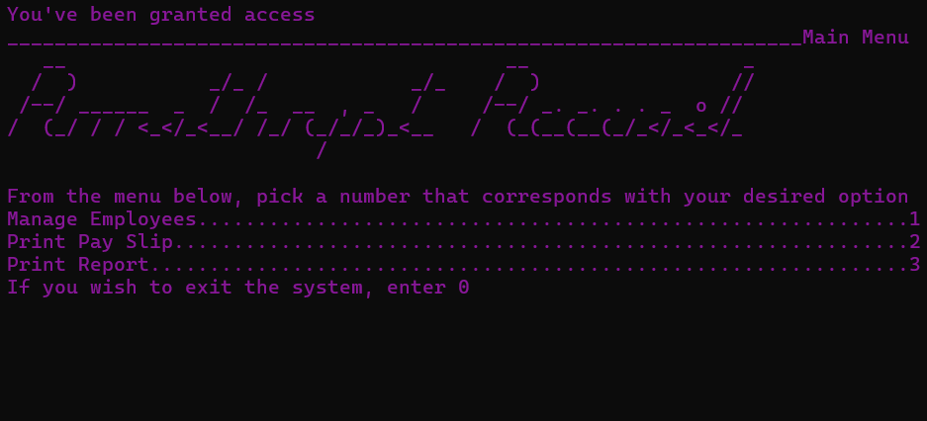
2 | 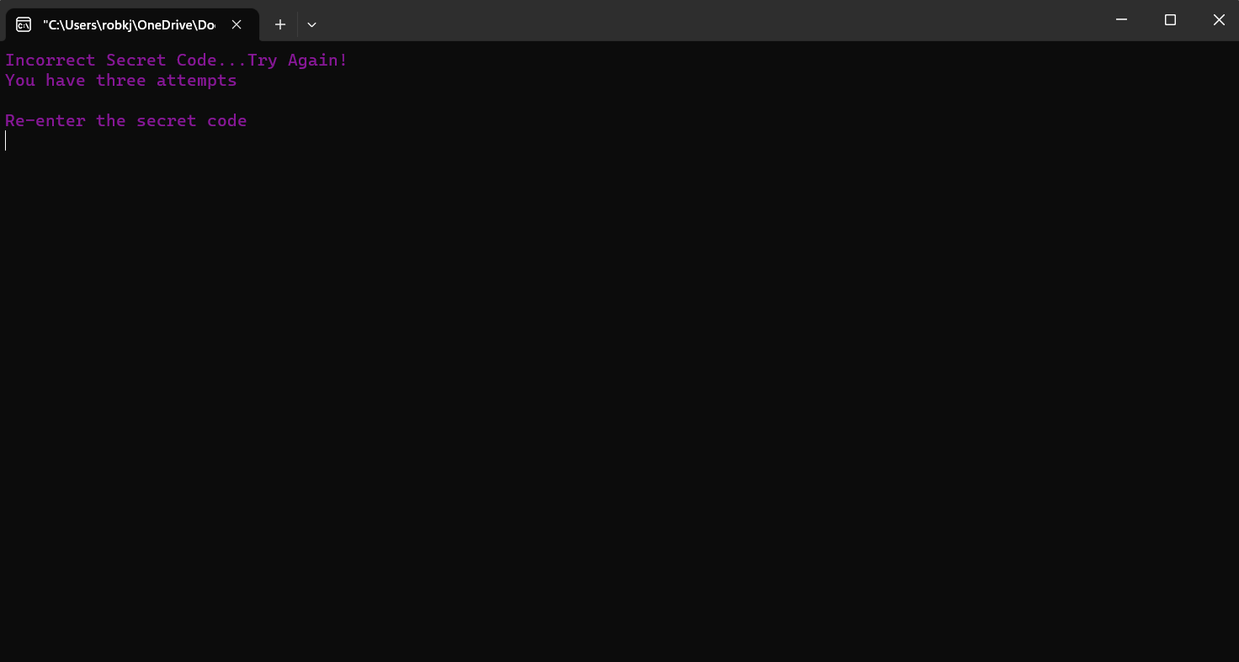
3 | 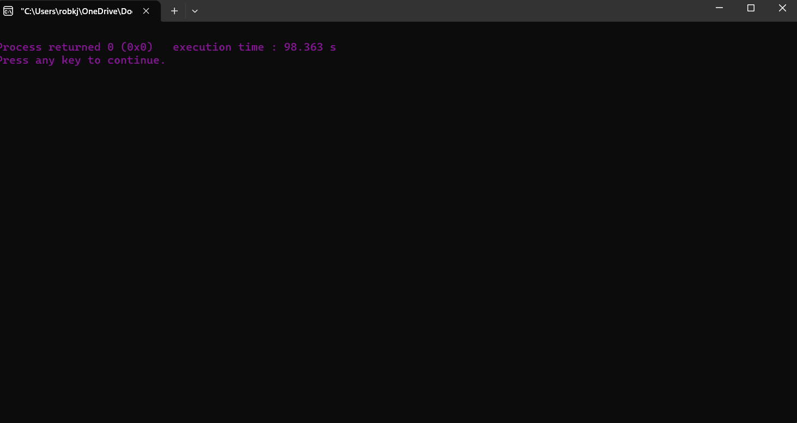
4
5 | 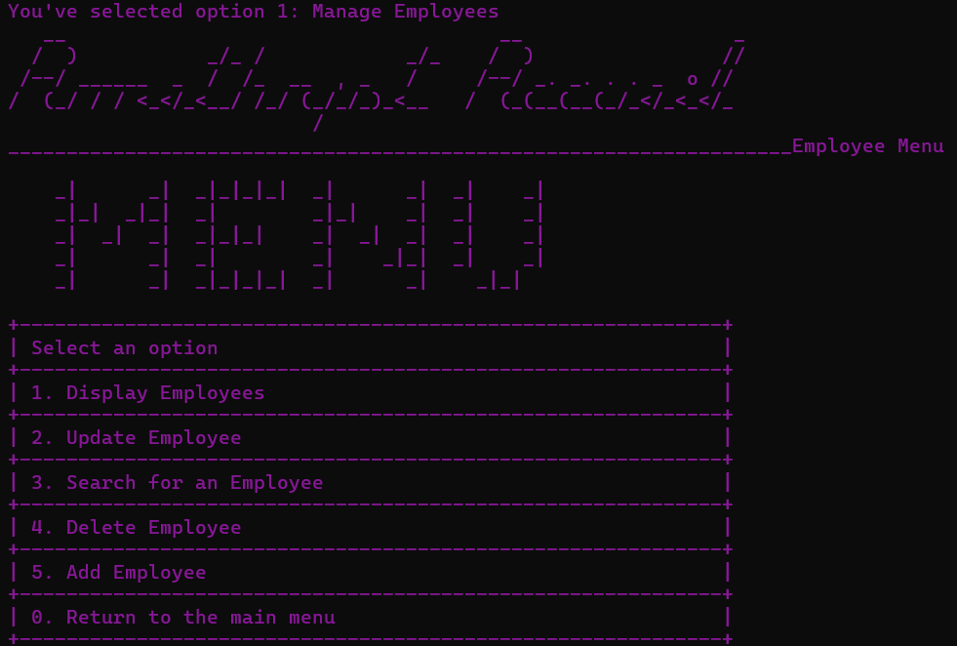
6 | 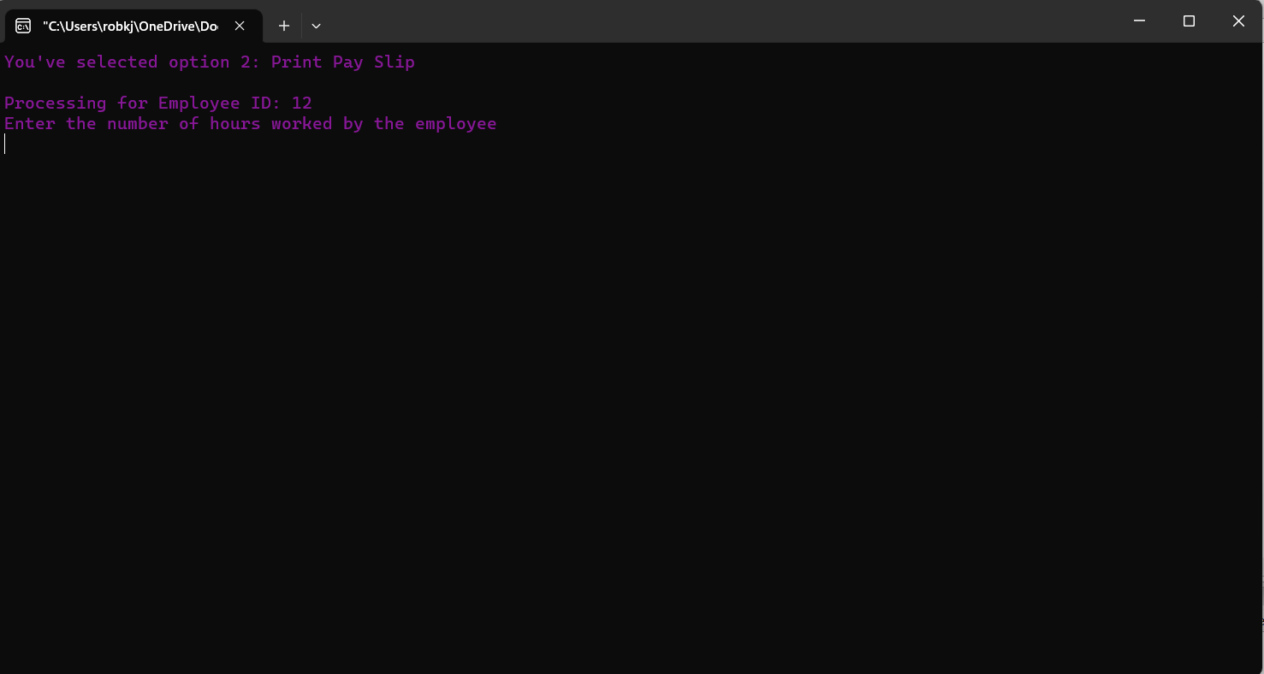
7 | 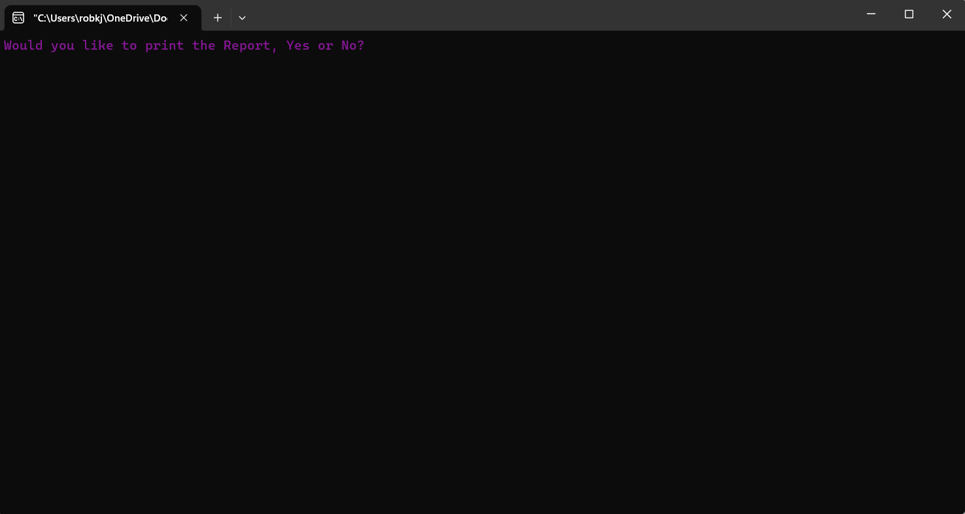
8 | 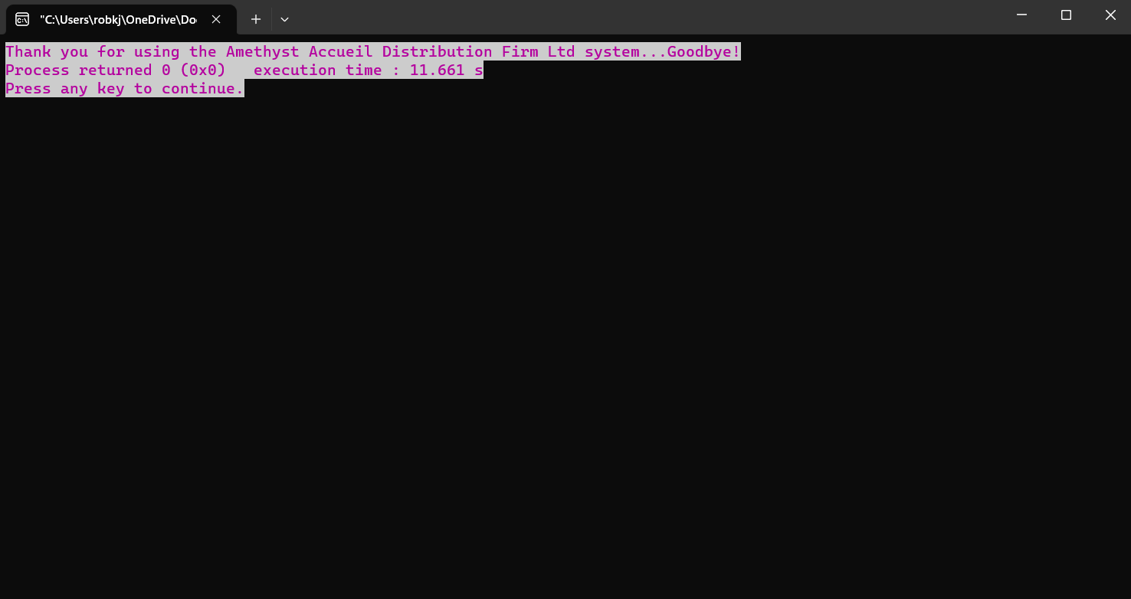
9 | 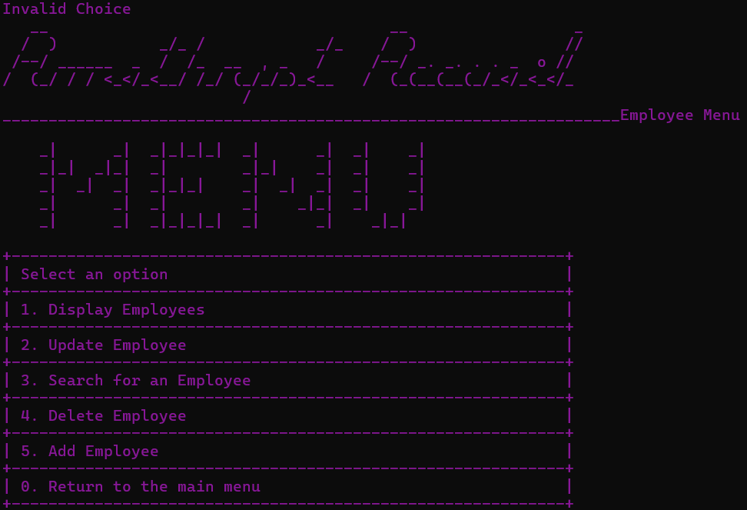
10
11
12 | 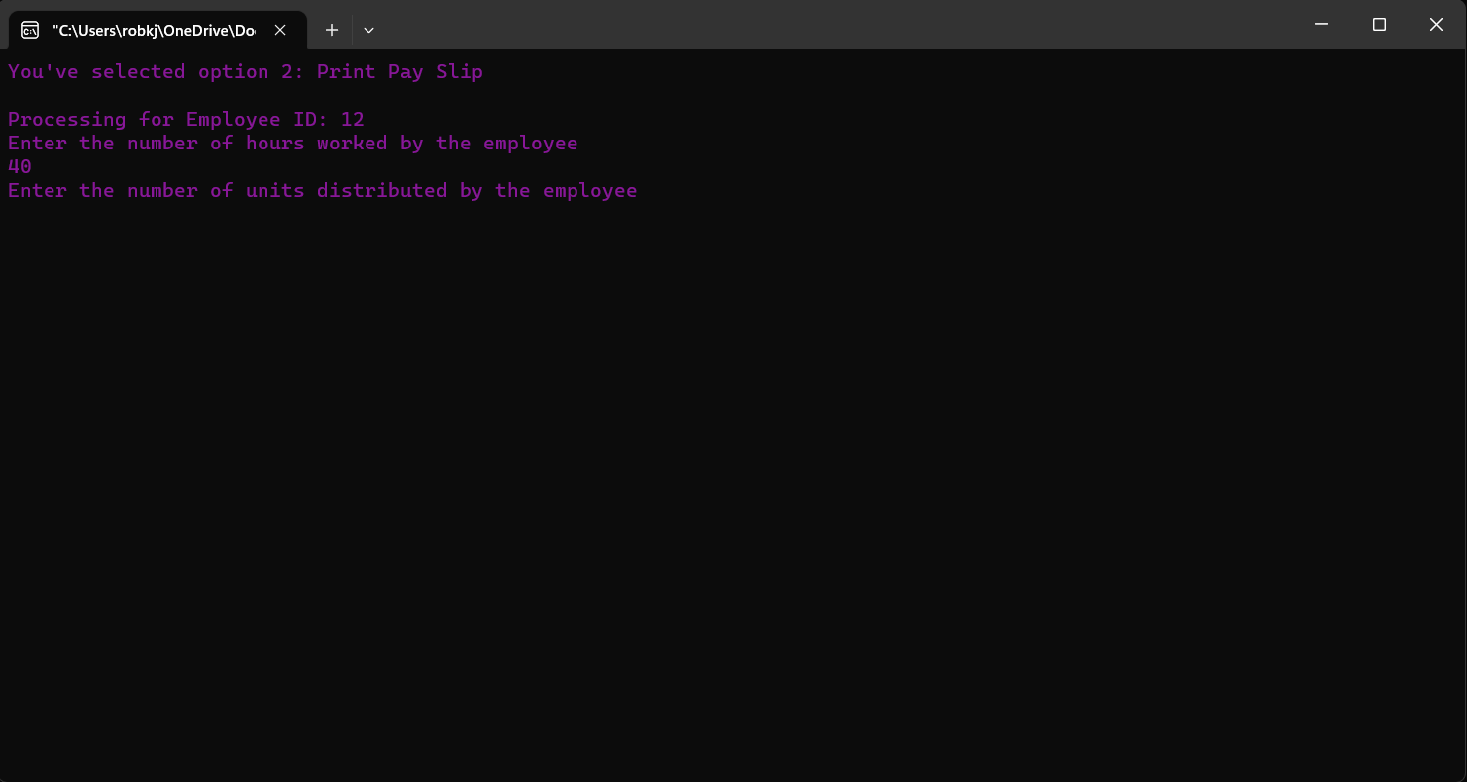
13 | 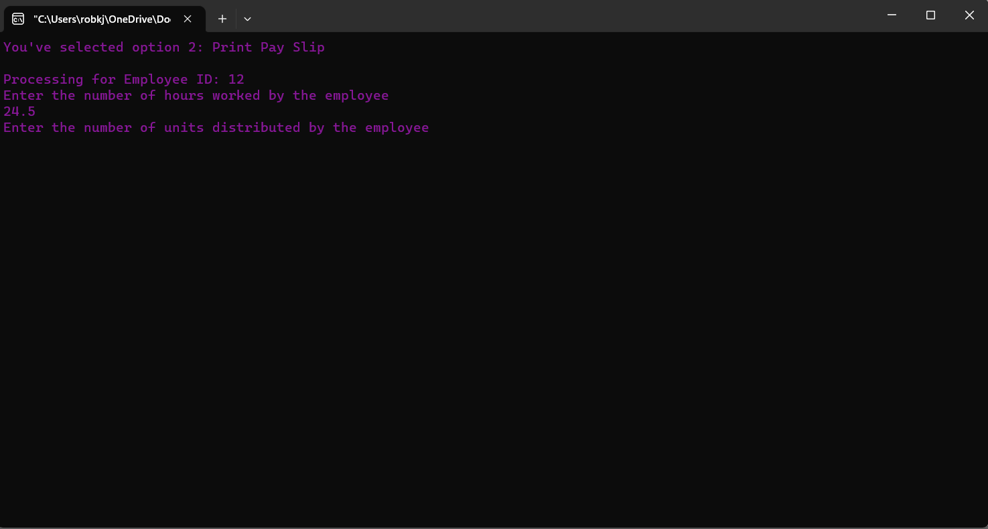
14 | 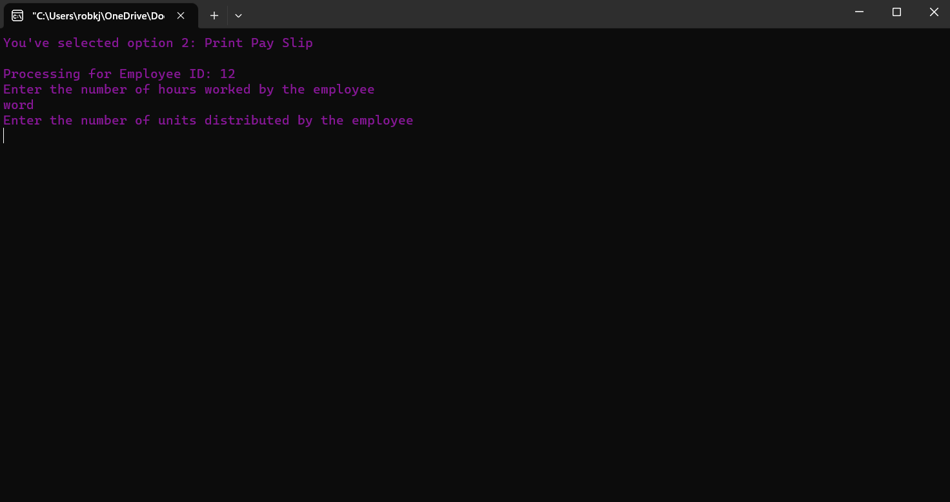
15 | 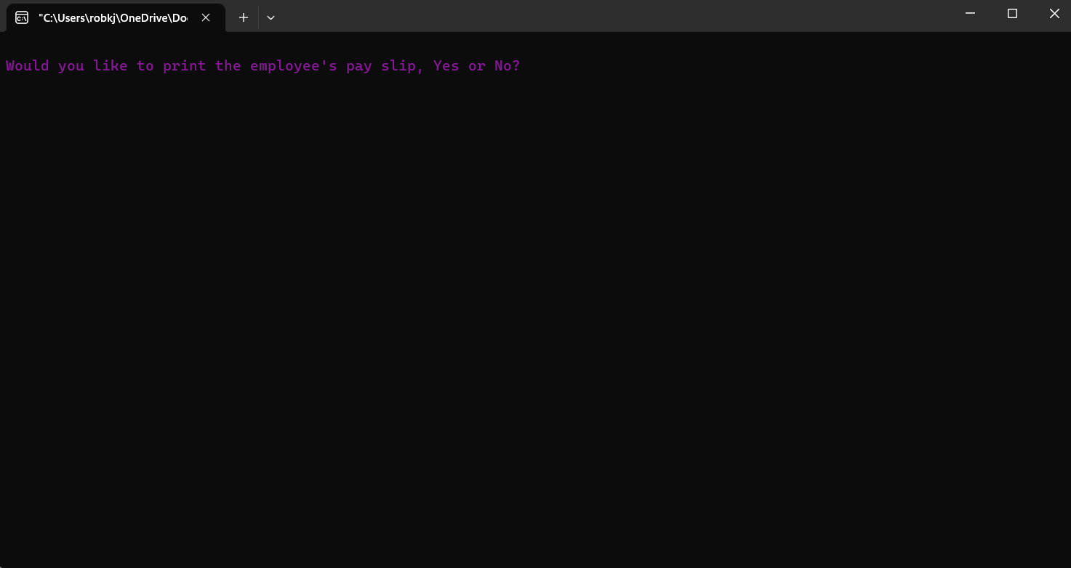
16 | 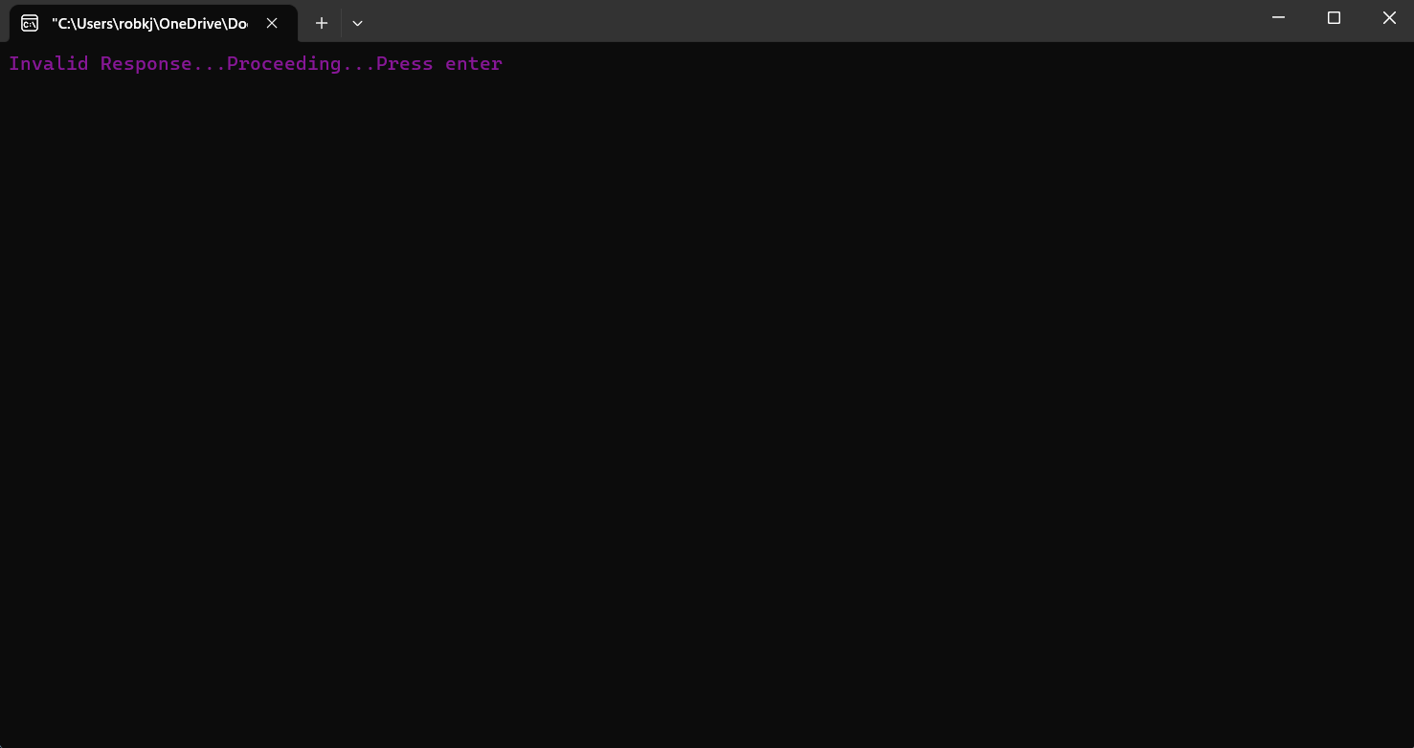
17
18 | 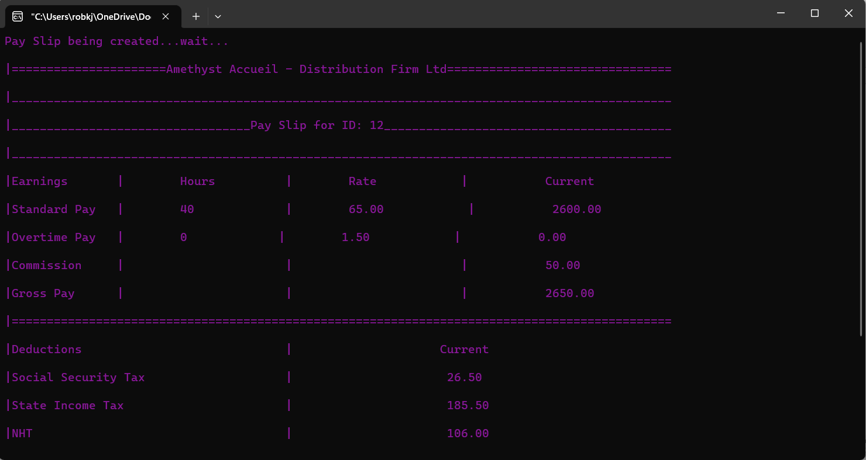
19 | 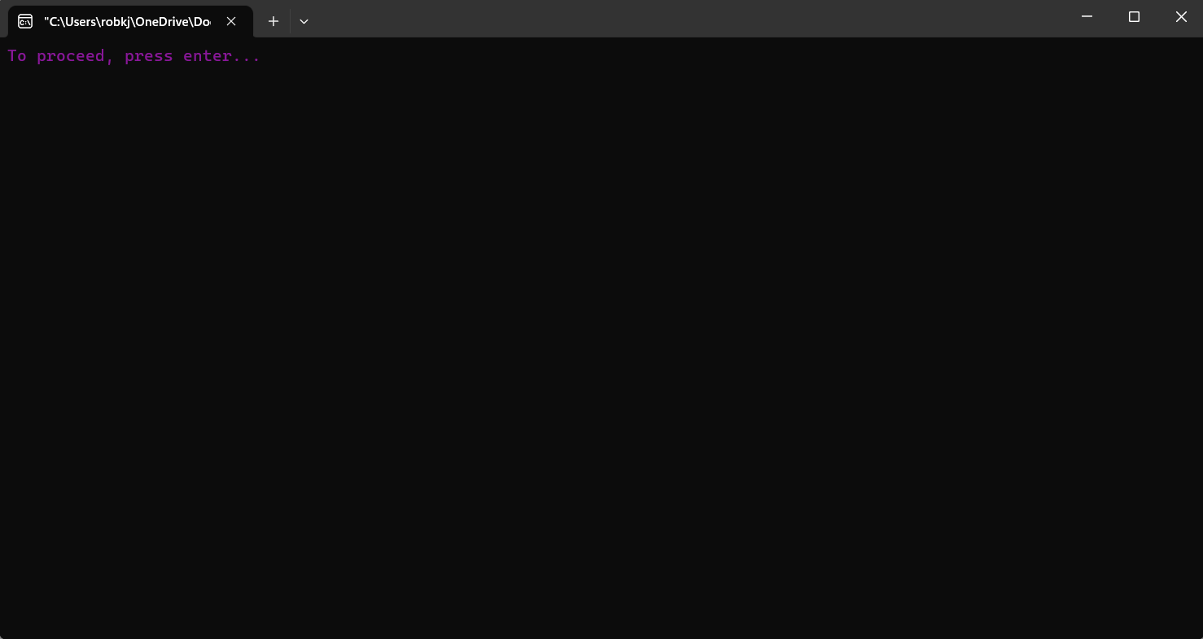
20
21
22 | 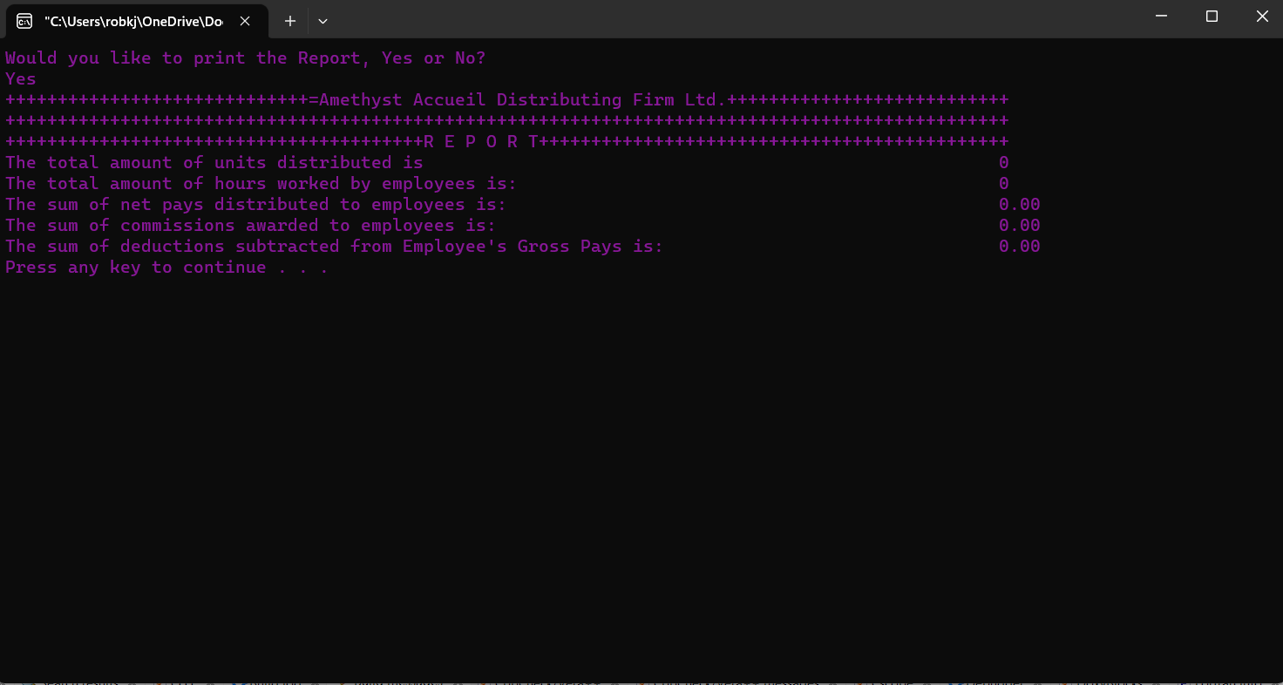
23
24
25
26 | 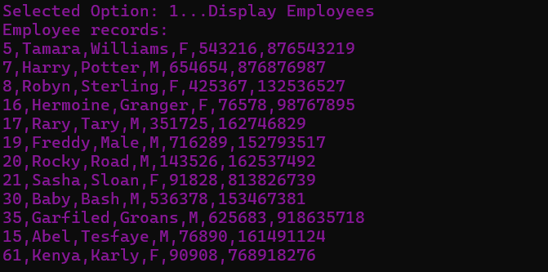
27 | 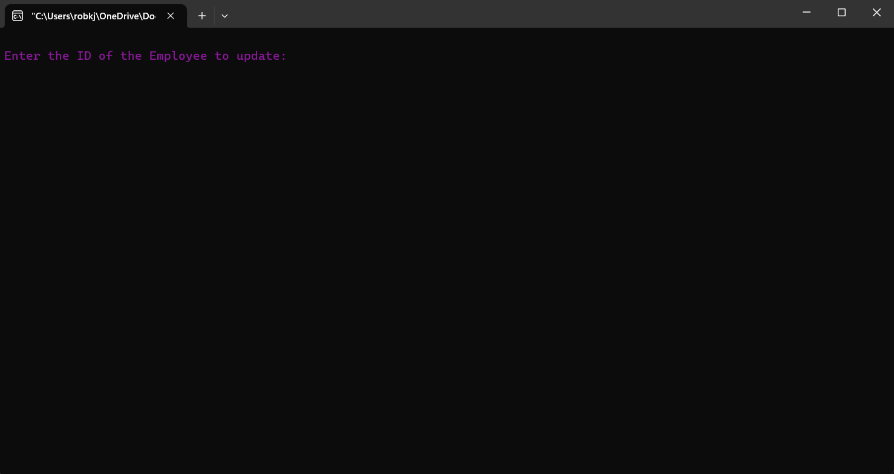
28 | 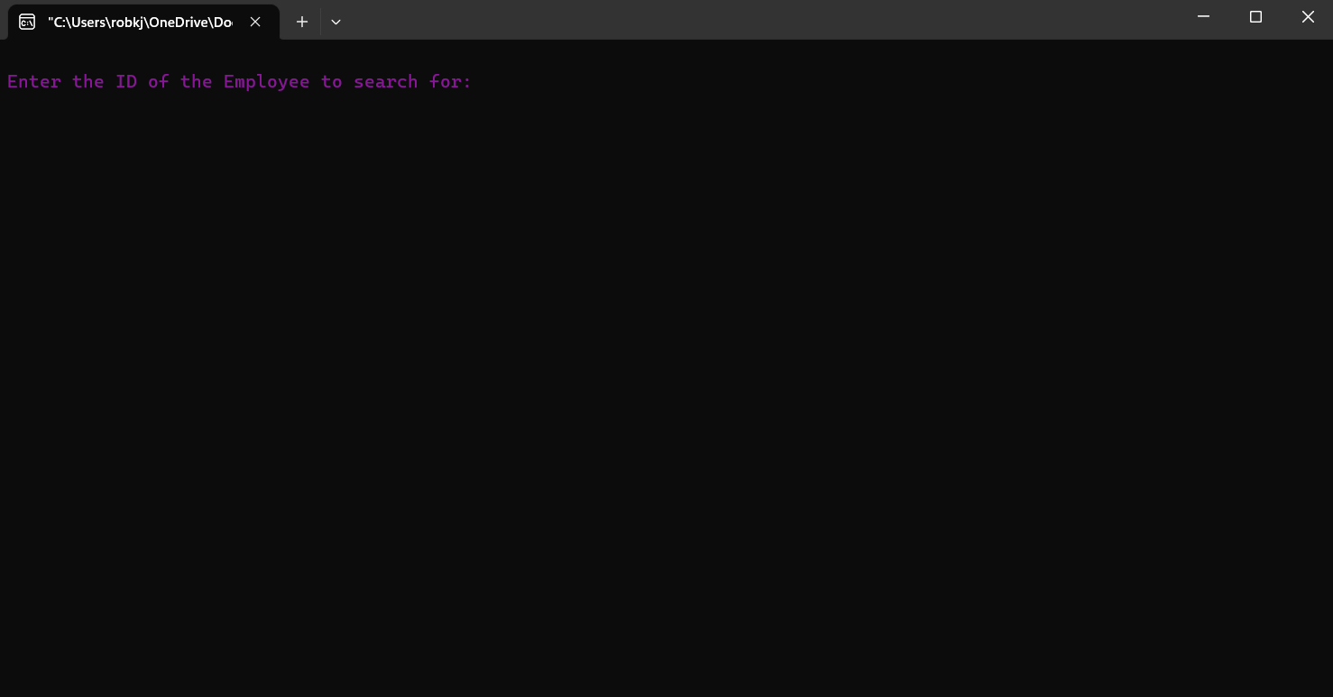
29 | 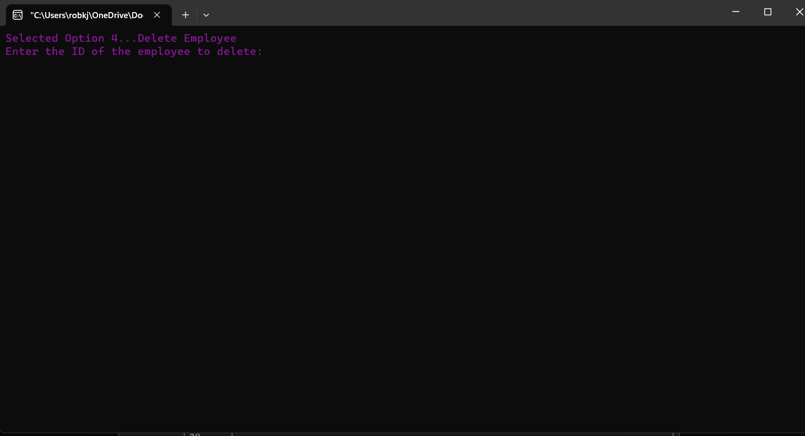
30 | 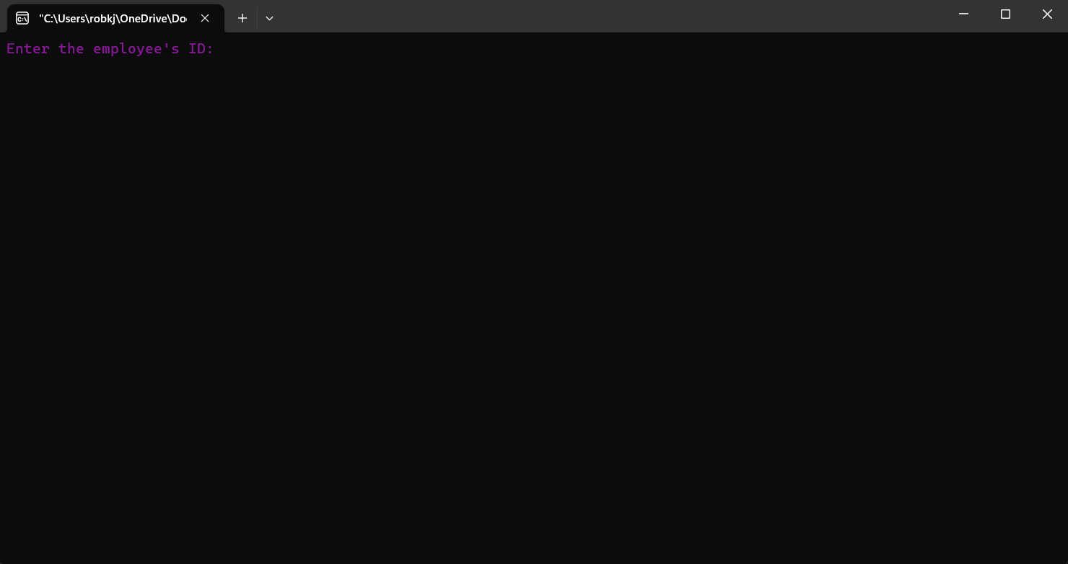
31
32
33 | 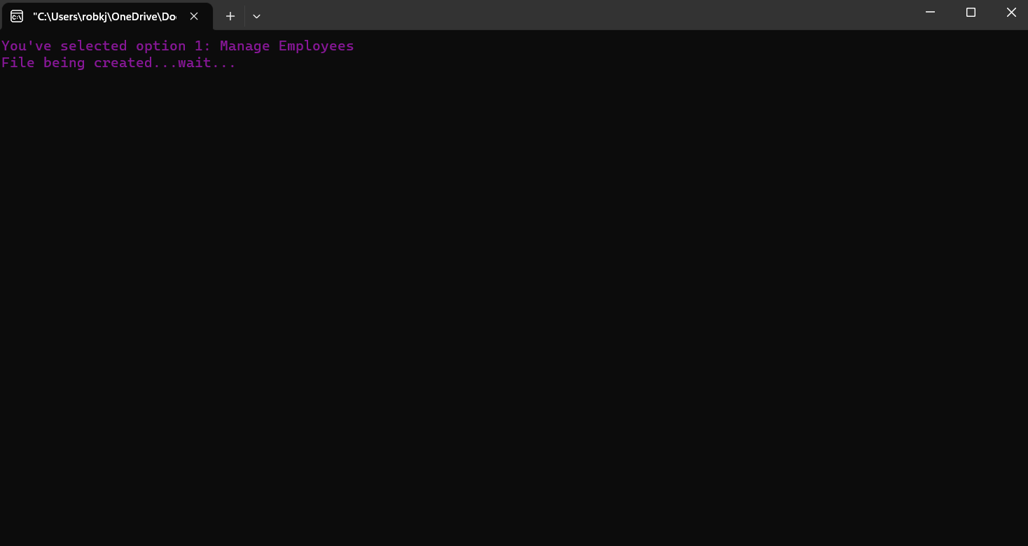

Error Trapping
Error trapping primarily focuses on handling file operations, input validation, and ensuring graceful program execution in various scenarios. Here are the areas where error trapping is implemented:

1. File Operations:
In functions like `PAYSLIP`, `report`, and `employf`, file operations such as opening, reading, writing, and closing files are performed. Error trapping is implemented to handle cases where files cannot be opened or created.
- Example:

file = fopen ("employee.txt", "r");
if (file == NULL){
printf ("An error occurred while opening the file. \n");
return;
}

2. Input Validation:
- Input validation is crucial for ensuring the program handles unexpected or invalid user inputs gracefully.
- In functions like `PAYSLIP`, `report`, and `employf`, user inputs are validated to ensure they are of the expected type and within acceptable ranges.
- Example:
printf("Enter the employee ID to search for: ");
scanf("%d", &search_num);

3. Function Return Values:
- Functions returning a value usually have error trapping to handle cases where the function fails to execute as expected.
- Example:
if (file4 == NULL) {
printf("An error has occurred while opening file4\n");
return;
}
4. Conditional Checks:
- Conditional checks are implemented to verify whether certain operations are successful or not, and actions are taken accordingly.
- Example:
if (found) {
printf("Record updated successfully.\n");
} else {
printf("Record doesn't seem to exist.\n");
remove("copy.employee.txt"); // Remove the temporary file
}

5. Loop Condition Checking:
The loop condition in the for loop ensures that the loop terminates when the user exceeds the maximum number of attempts or successfully enters the correct password.
Example:
for (x = 1;x <= 3 && ent_pass != 5791; x++)

6. Error Message Printing:
Error messages are printed when the user enters an incorrect password or when the file operations encounter issues.
Example:

printf ("Incorrect Secret Code...Try Again!\n");

Correct Output
Correct Output Example 1: Wherein, the data added to the file is coherent with what is displayed on the program and as well as saved in the file.
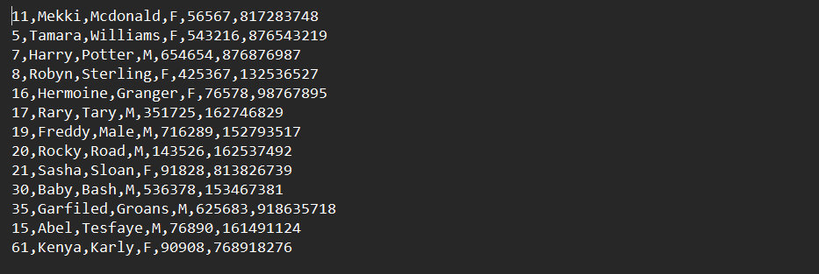
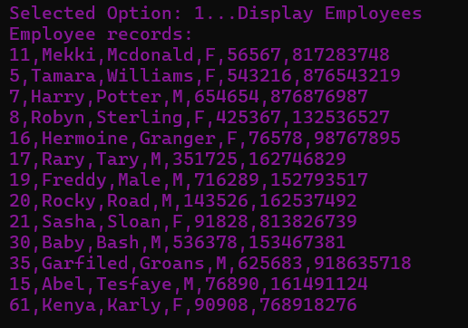

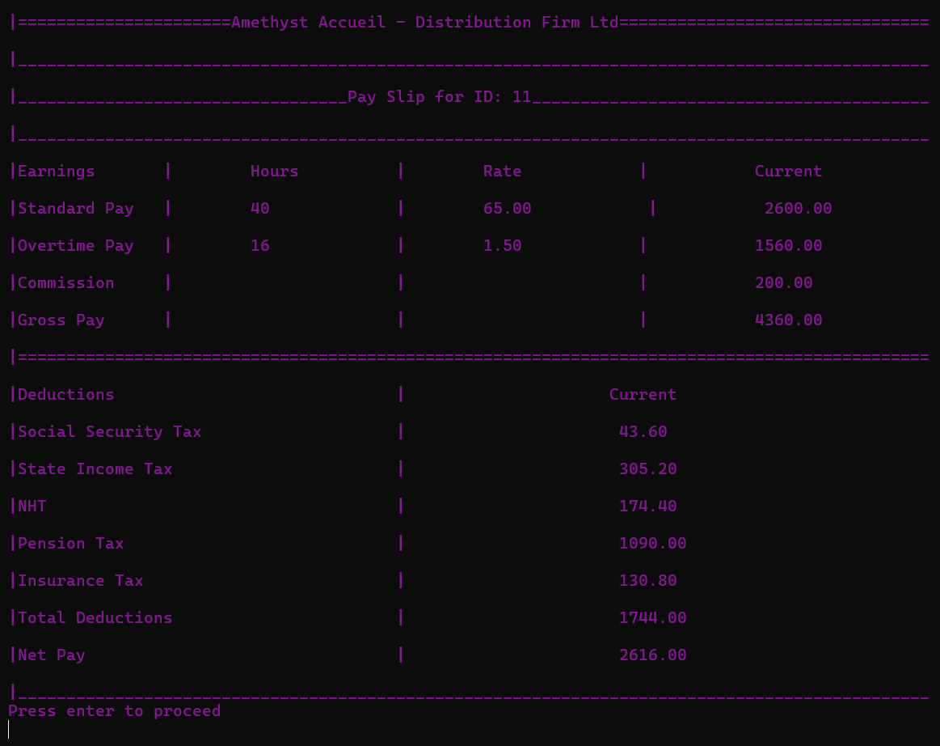
Correct Output Example 2: Wherein ID 11 worked a total of 56 hours that was inputted into the system, these hours were accurately calculated to print his Payslip, and coherent with that, the Payslip stored in the file.

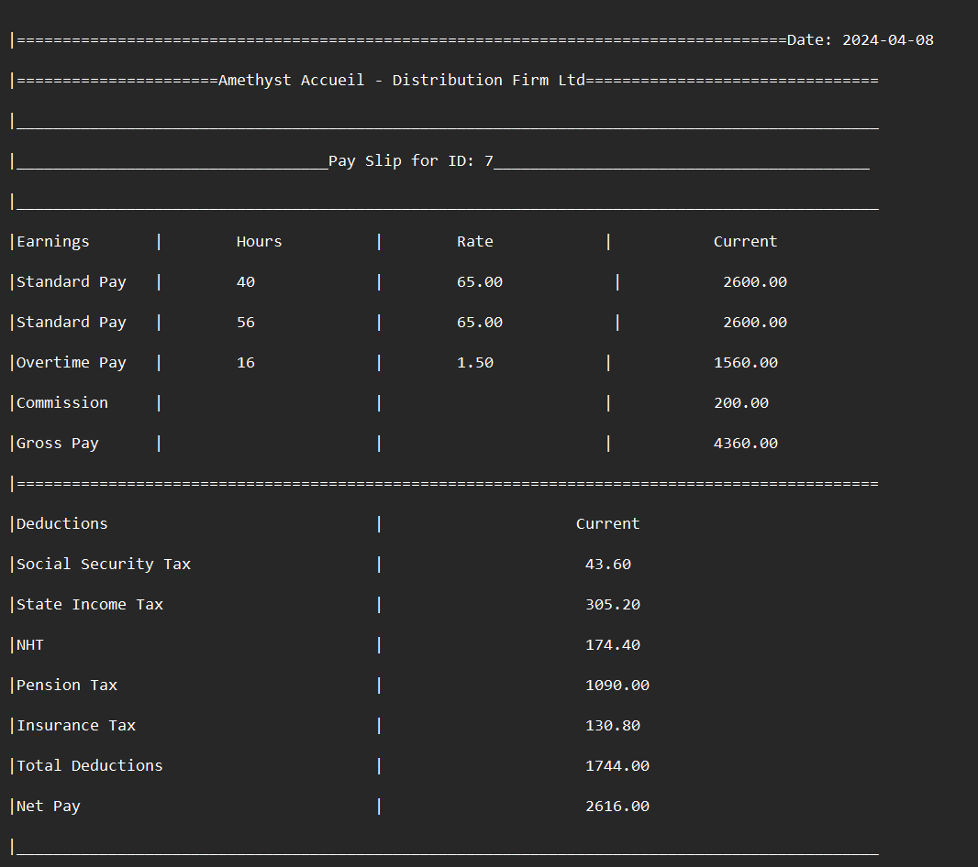

Usability
Usability Example 1: Displays the message of “You’ve been granted access” to provide confirmation to the user of their access granted, followed by a header that displays the name of the firm in a large font size. The menu comprises of menu options alongside numbers to make the user experience easier and more efficient in lieu of typing out the entire menu option itself.

Usability Example 2: Similarly to usability example two remains consistent, to provide a cohesive set of prompts to the user, which makes the content more predictable and easier to maneuver around.

Conclusion

Amethyst Accueil Distribution Firm Ltd encountered significant issues with their system's key features, including malfunctioning functionalities like Display, Add, Delete, Update, and Search, as well as a restrictive six-employee limit. Additionally, problems with payslip and report functions arose, such as inaccessible filed content and limited payslip generation.

However, strategic improvements have resulted in a much more effective and efficient system. The previously faulty features now operate seamlessly, and the employee limit has been eliminated to accommodate the firm's growth. Payslip and report functions have been enhanced for accessibility and flexibility.

Looking forward, embracing technological advancements in graphic design and programming can further improve the system's user experience and functionality. Suggestions for improvement include introducing emergency management and inventory functions and implementing network integration for enhanced data sharing.

By continually adapting to technological advancements, Amethyst Accueil Distribution Firm Ltd can ensure its system remains robust and capable of meeting evolving user needs.

Appendix
Questionnaire for Employees

- What is your age?
- How long have you been operating as an employee for the Amethyst Accueil company?
- On a scale of 1 to 10, how would you rate the clarity and ease of understanding the new digital payroll system.
- Previously, Amethyst Accueil was purely paper based in recording and distribution on information, data, and records, as of recently, their system has adopted a partial digital system. With this knowledge, do you consider the information to be of a more accurate and premium quality? (Yes or No)
- In relation to the previous question, please give a reason as to why this is answer.
- How satisfied are you with the accessibility of your digital payroll system? If yes, please specify.
- Do you find that the software is aesthetically pleasing to the eyes?
- Are there any features in the digital payroll system that you find particularly beneficial or challenging?
- Are there specific areas in which you believe additional training or support would be beneficial for a smoother transition?
- Have you experienced any disruptions in accessing the digital payroll system, and if so, how were these issues resolved?
- In your opinion, what steps could be taken to enhance employee engagement and understanding of the digital payroll system?
- Please state any other concerns/queries and such that you may have as it relates to the current system.
Thank you for taking your time to fill out the questionnaire. Your responses are much valued.

Amethyst Accueil.

Interview for Management

- In what ways has the digital system improved decision-making and strategic planning related to financial management?
- How do you assess the accuracy and reliability of the data generated by the digital payroll system compared to the previous paper-based system?
- Can you discuss any strategies for continuous improvement and innovation in the use of the digital system for payroll and employee record management?
- How has the digital system adapted to changes in organizational structure, workforce size, or regulatory requirements, ensuring continued effectiveness?
- Can you discuss specific objectives related to employee record management that the organization aims to achieve through the digital system?

Thank you for taking your time to answer this interview. Your responses are much valued.

Amethyst Accueil.

